**HIVE Queries and Screenshots**

**1.** **Movie**

CREATE TABLE Movie(

MovieID Int,

StatusID Int,

CertificateID Int,

Name String,

Rating Float,

UserVotes Int,

Metascore Int,

StoryLine String,

Runtime String,

Color String,

NegativeFormat String,

Budget String,

IsAmazonAvailableFlag int,

ReleaseString String,

Rank Int,

Camera String ,

Laboratory String,

Cinematography String,

PrintedFilmFormat String,

MovieYear int,

ModifiedString String,

ModifiedBy String

)

ROW FORMAT DELIMITED FIELDS

TERMINATED BY ',' STORED AS TEXTFILE;

LOAD DATA INPATH '/user/IMDb/Movie.csv' OVERWRITE INTO TABLE Movie;

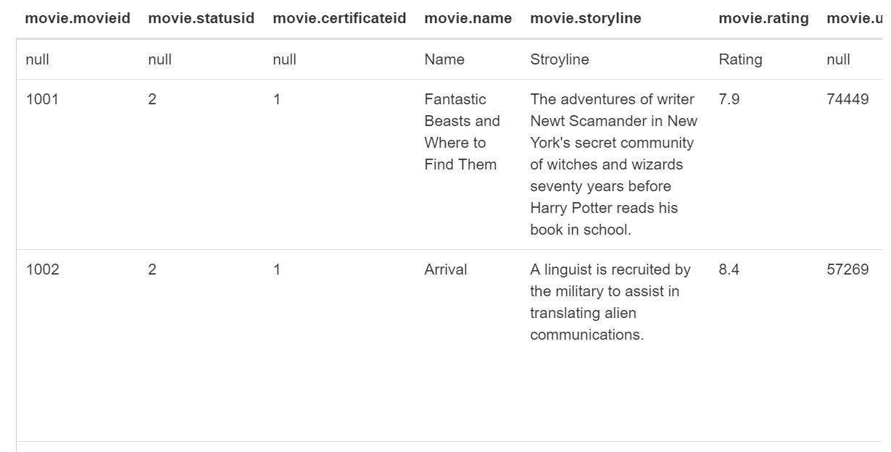

-----------------------------------------------------------------------------------------------------------

**2. MovieTrailer**

CREATE TABLE MovieTrailer(

TrailerID INT ,

Name String ,

ReleaseString String ,

Rating Float,

TrailerNum INT ,

MovieID INT ,

TrailerRunTime String,

TrailerLink String,

ModifiedString String ,

ModifiedBy String

)

ROW FORMAT DELIMITED FIELDS

TERMINATED BY ',' STORED AS TEXTFILE;

LOAD DATA INPATH '/user/IMDb/MovieTrailor.csv' OVERWRITE INTO TABLE MovieTrailer;

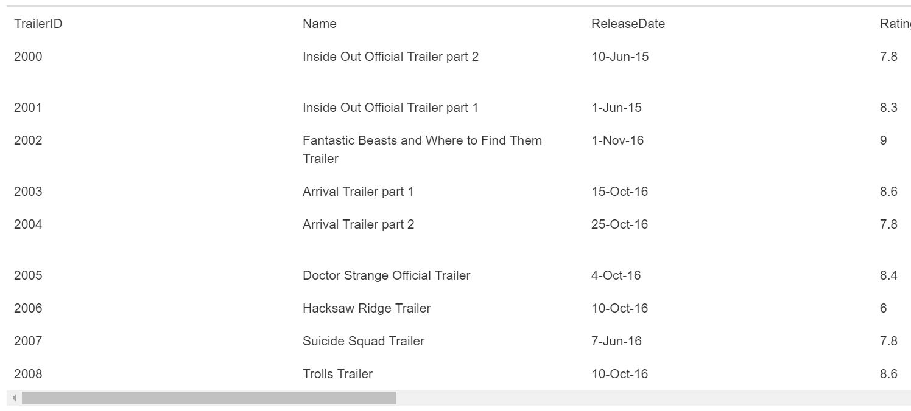

---------------------------------------------------------------------------------------------------------------------

3. **MovieTVStatusRef**

CREATE TABLE MovieTVStatusRef (

StatusID INT,

Status String ,

ModifiedString String ,

ModifiedBy String

)

ROW FORMAT DELIMITED FIELDS

TERMINATED BY ',' STORED AS TEXTFILE;

LOAD DATA INPATH '/user/IMDb/MovieStatusRef.csv' OVERWRITE INTO TABLE MovieTVStatusRef;

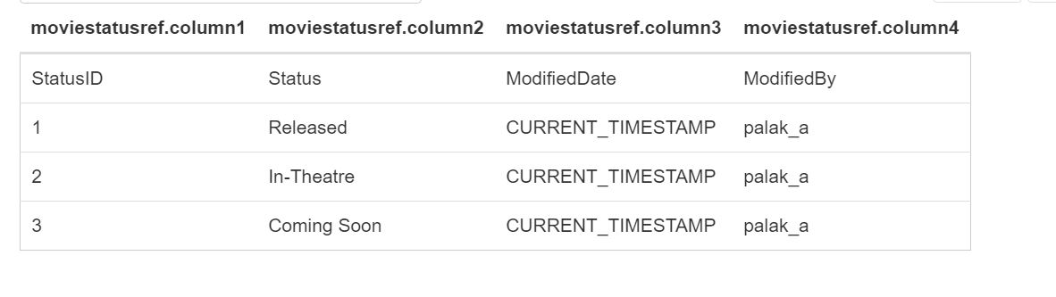

---------------------------------------------------------------------------------------------------------------------

4. **Review**

CREATE TABLE Review (

ReviewID INT,

PersonID INT,

MovieID Int,

TVShowID Int,

ReviewType String ,

Review String,

ModifiedString String ,

ModifiedBy String

)

ROW FORMAT DELIMITED FIELDS

TERMINATED BY ',' STORED AS TEXTFILE;

LOAD DATA INPATH '/user/IMDb/Review.csv' OVERWRITE INTO TABLE Review;

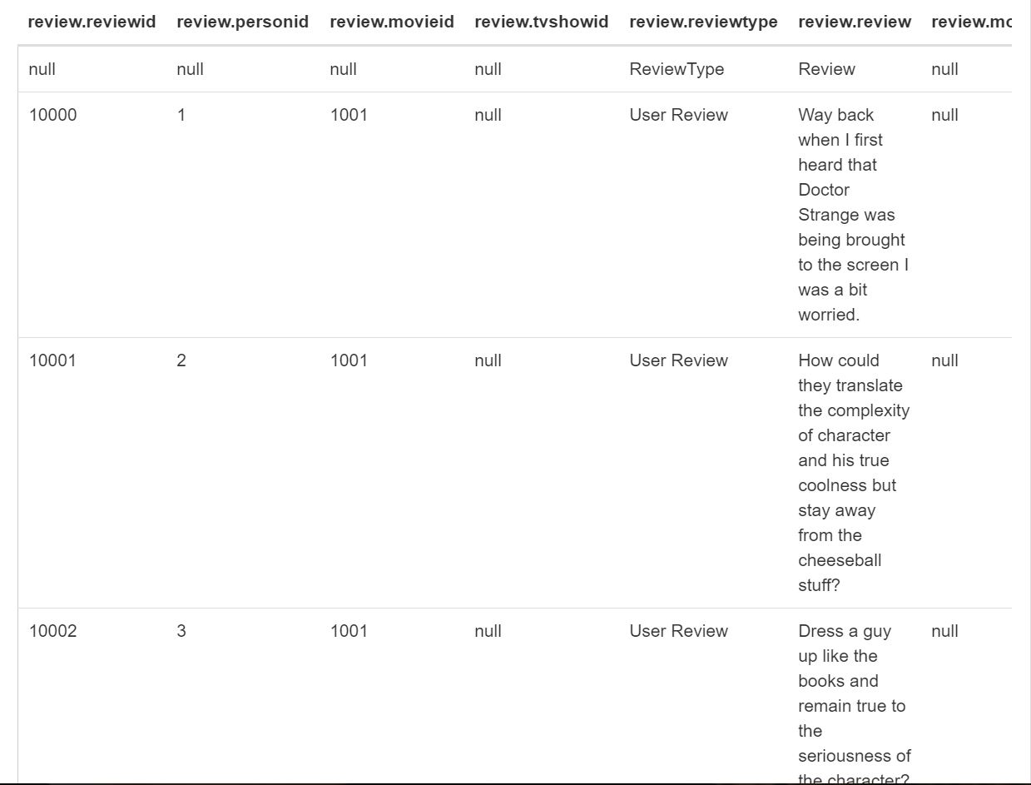

---------------------------------------------------------------------------------------------------------------------

5. **Language**

CREATE TABLE Language (

LanguageID Int,

Language String ,

ModifiedString String,

ModifiedBy String

)

ROW FORMAT DELIMITED FIELDS

TERMINATED BY ',' STORED AS TEXTFILE;

LOAD DATA INPATH '/user/IMDb/Language.csv' OVERWRITE INTO TABLE Language;

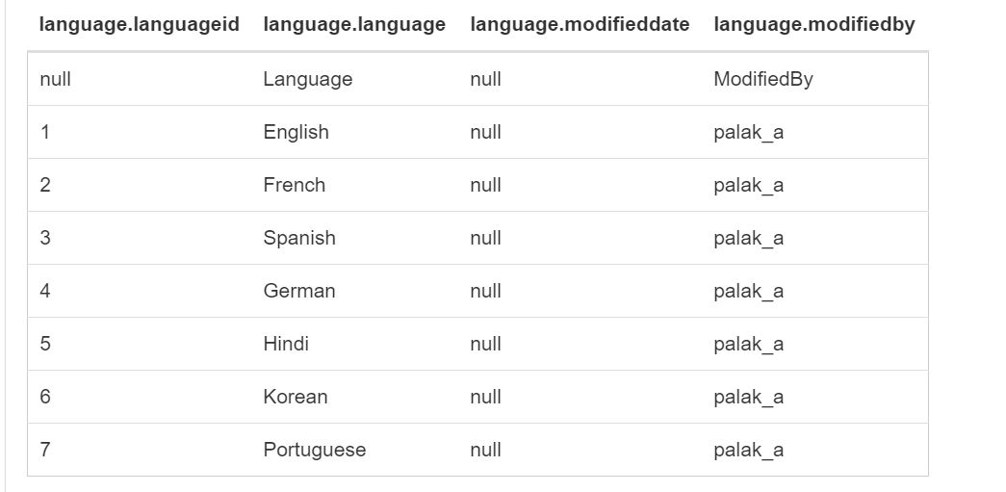

---------------------------------------------------------------------------------------------------------------------

6. **ProductionHouse**

CREATE TABLE ProductionHouse (

ProductionID Int,

ProductioName String,

ModifiedString String,

ModifiedBy String

)

ROW FORMAT DELIMITED FIELDS

TERMINATED BY ',' STORED AS TEXTFILE;

LOAD DATA INPATH '/user/IMDb/ProductionHouse.csv' OVERWRITE INTO TABLE ProductionHouse;

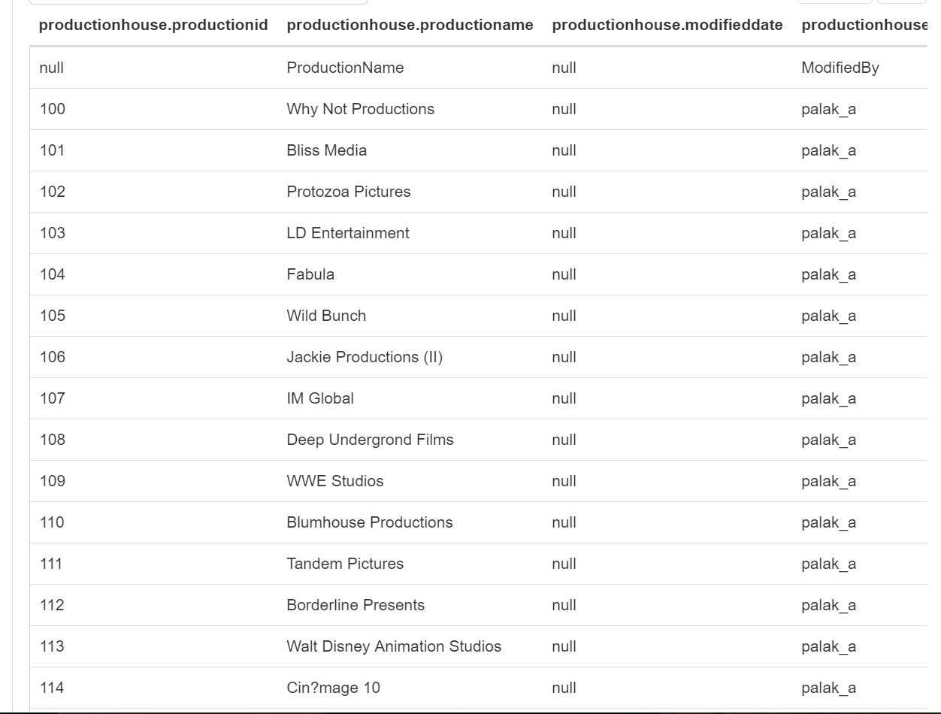

---------------------------------------------------------------------------------------------------------------------

**7. NewsArticle**

CREATE TABLE NewsArticle (

ArticleID Int,

Article String,

ModifiedString String,

ModifiedBy String,

MovieID Int

)

ROW FORMAT DELIMITED FIELDS

TERMINATED BY ',' STORED AS TEXTFILE;

LOAD DATA INPATH '/user/IMDb/News.csv' OVERWRITE INTO TABLE News;

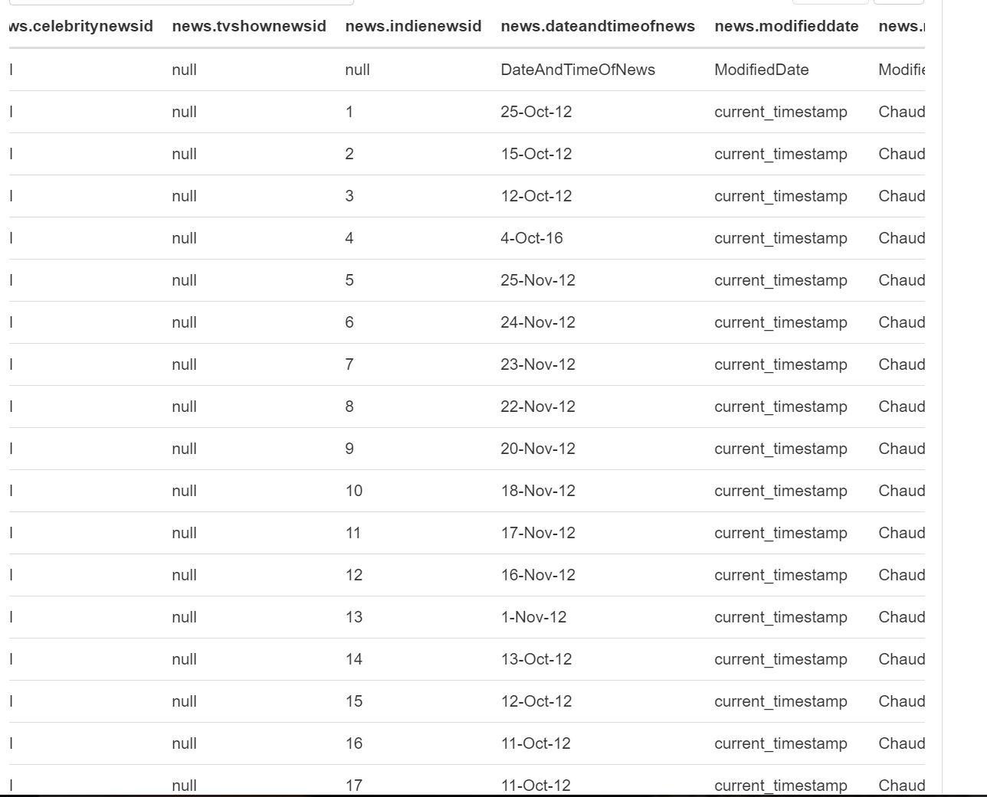

---------------------------------------------------------------------------------------------------------------------

**8. SoundMixRef**

CREATE TABLE SoundMixRef (

SoundMixID Int,

SoundMixName String,

ModifiedString String,

ModifiedBy String

)

ROW FORMAT DELIMITED FIELDS

TERMINATED BY ',' STORED AS TEXTFILE;

LOAD DATA INPATH '/user/IMDb/SoundMixRef.csv' OVERWRITE INTO TABLE SoundMixRef;

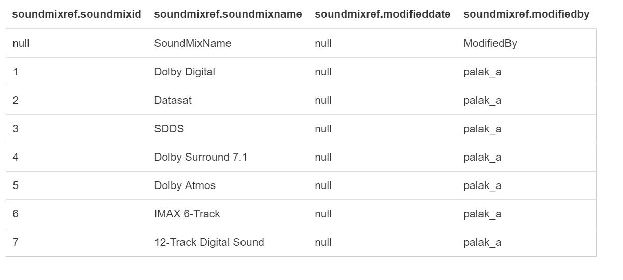

---------------------------------------------------------------------------------------------------------------------

**9. Genre**

CREATE TABLE Genre (

GenreID Int,

Genre String,

ModifiedString String,

ModifiedBy String

)

ROW FORMAT DELIMITED FIELDS

TERMINATED BY ',' STORED AS TEXTFILE;

LOAD DATA INPATH '/user/IMDb/Genre.csv' OVERWRITE INTO TABLE Genre;

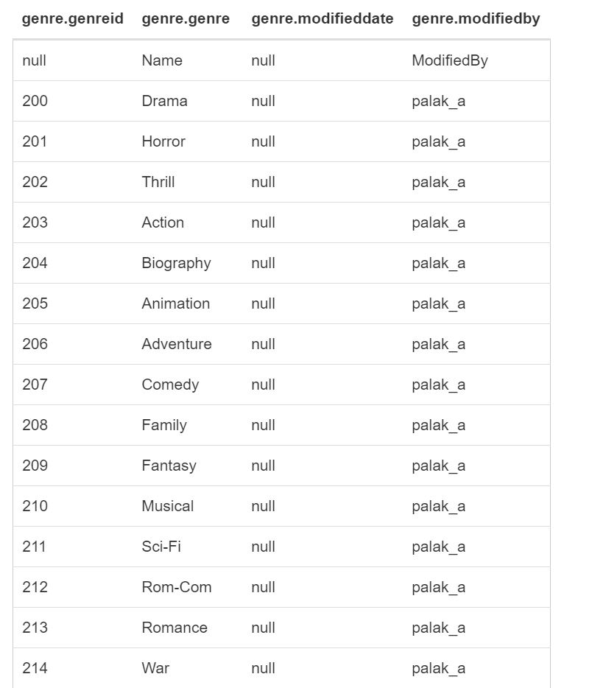

---------------------------------------------------------------------------------------------------------------------

**10. MovieTVSoundMix**

CREATE TABLE MovieTVSoundMix (

SoundMixID Int,

MovieID Int,

TVShowID Int,

ModifiedString String,

ModifiedBy String

)

ROW FORMAT DELIMITED FIELDS

TERMINATED BY ',' STORED AS TEXTFILE;

LOAD DATA INPATH '/user/IMDb/MovieTVSoundMix.csv' OVERWRITE INTO TABLE MovieTVSoundMix;

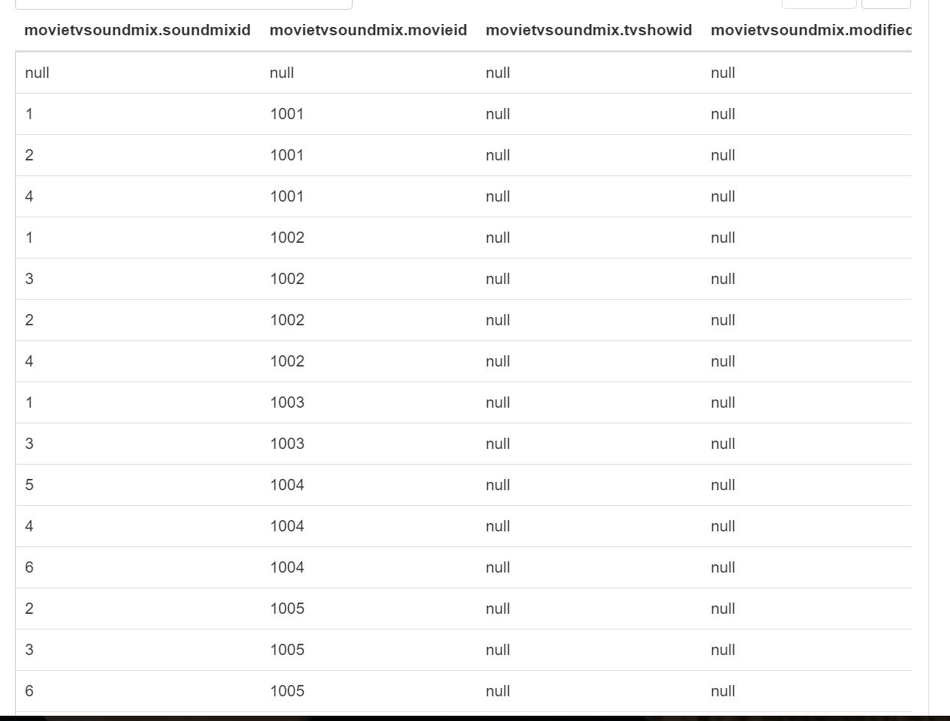

---------------------------------------------------------------------------------------------------------------------

**11. MovieTVGenre**

CREATE TABLE MovieTVGenre (

GenreID Int,

MovieID Int,

TVShowID Int,

ModifiedString String ,

ModifiedBy String

)

ROW FORMAT DELIMITED FIELDS

TERMINATED BY ',' STORED AS TEXTFILE;

LOAD DATA INPATH '/user/IMDb/MovieTVGenre.csv' OVERWRITE INTO TABLE MovieTVGenre;

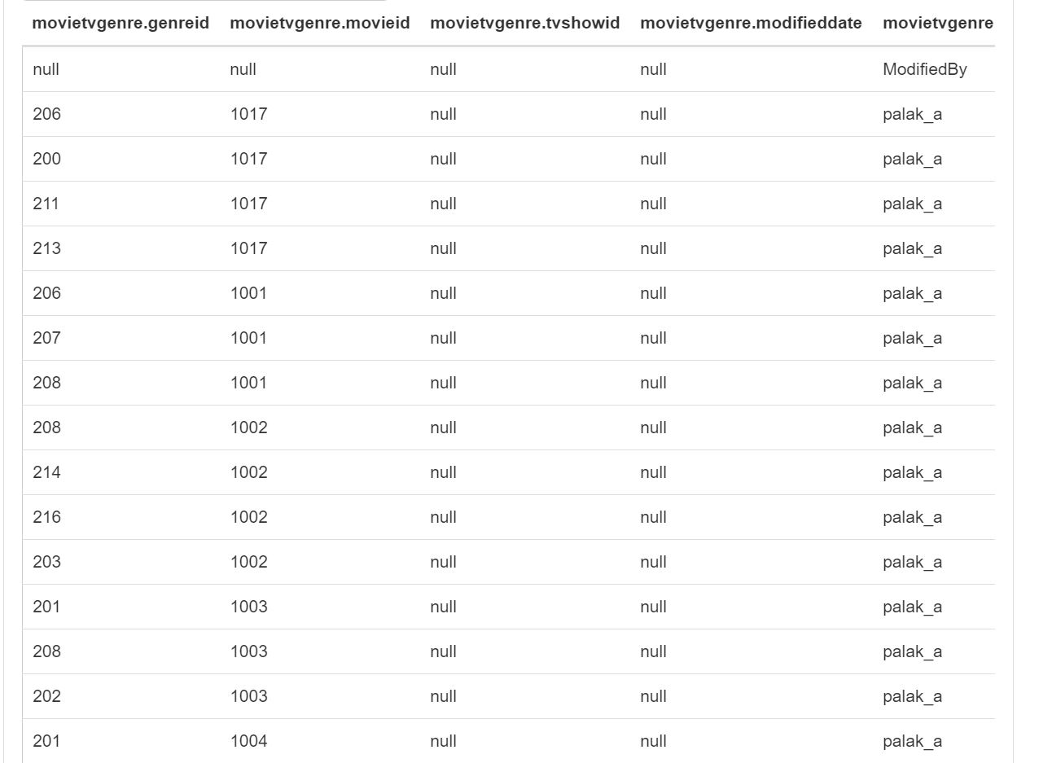

---------------------------------------------------------------------------------------------------------------------

**12. AwardType**

CREATE TABLE AwardType (

AwardTypeID Int,

AwardTypeName String,

Year String ,

ModifiedString String,

ModifiedBy String

)

ROW FORMAT DELIMITED FIELDS

TERMINATED BY ',' STORED AS TEXTFILE;

LOAD DATA INPATH '/user/IMDb/AwardType.csv' OVERWRITE INTO TABLE AwardType

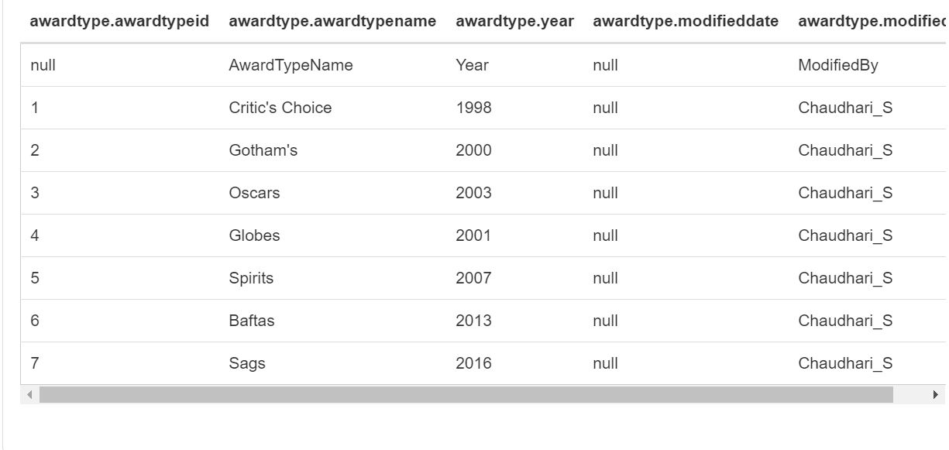

---------------------------------------------------------------------------------------------------------------------

**13. AwardStatusRef**

CREATE TABLE AwardStatusRef (

StatusID Int,

Status String,

ModifiedString String ,

ModifiedBy String

)

ROW FORMAT DELIMITED FIELDS

TERMINATED BY ',' STORED AS TEXTFILE;

LOAD DATA INPATH '/user/IMDb/AwardStatusRef.csv' OVERWRITE INTO TABLE AwardStatusRef;

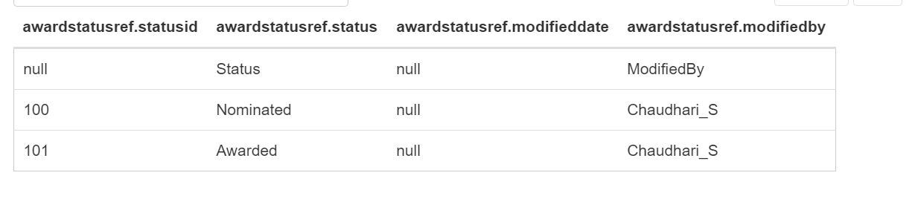

---------------------------------------------------------------------------------------------------------------------

**14. AwardTypeCategory**

CREATE TABLE AwardTypeCategory (

AwardTypeCategoryID Int,

AwardTypeID Int,

AwardTypeCategoryName String ,

ModifiedString String ,

ModifiedBy String

)

ROW FORMAT DELIMITED FIELDS

TERMINATED BY ',' STORED AS TEXTFILE;

LOAD DATA INPATH '/user/IMDb/AwardTypeCategory.csv' OVERWRITE INTO TABLE AwardTypeCategory;

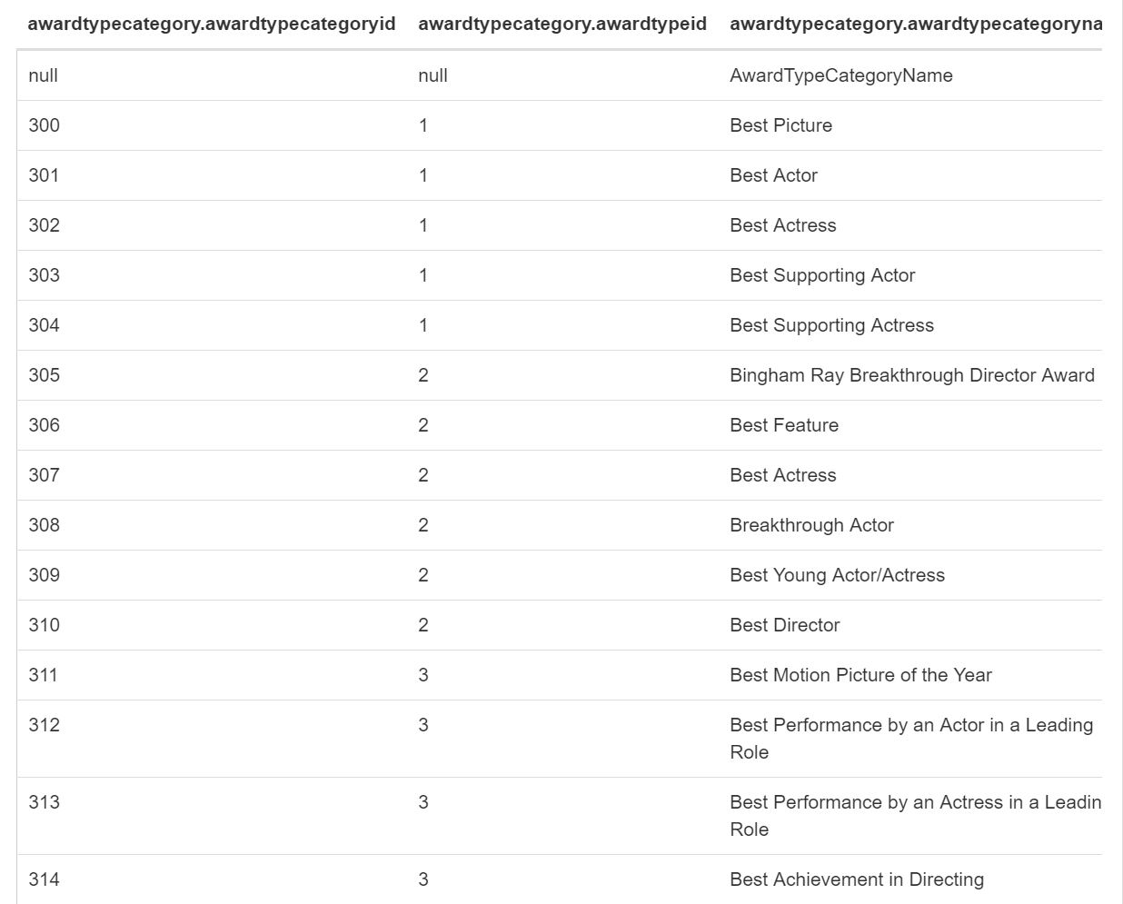

---------------------------------------------------------------------------------------------------------------------

**15. Award**

CREATE TABLE Award (

AwardID Int,

AwardTypeCategoryID Int,

AwardTypeID Int,

StatusID Int,

MovieID Int,

CelebrityID Int,

String_Award String ,

ModifiedString String,

ModifiedBy String

)

ROW FORMAT DELIMITED FIELDS

TERMINATED BY ',' STORED AS TEXTFILE;

LOAD DATA INPATH '/user/IMDb/Award.csv' OVERWRITE INTO TABLE Award;

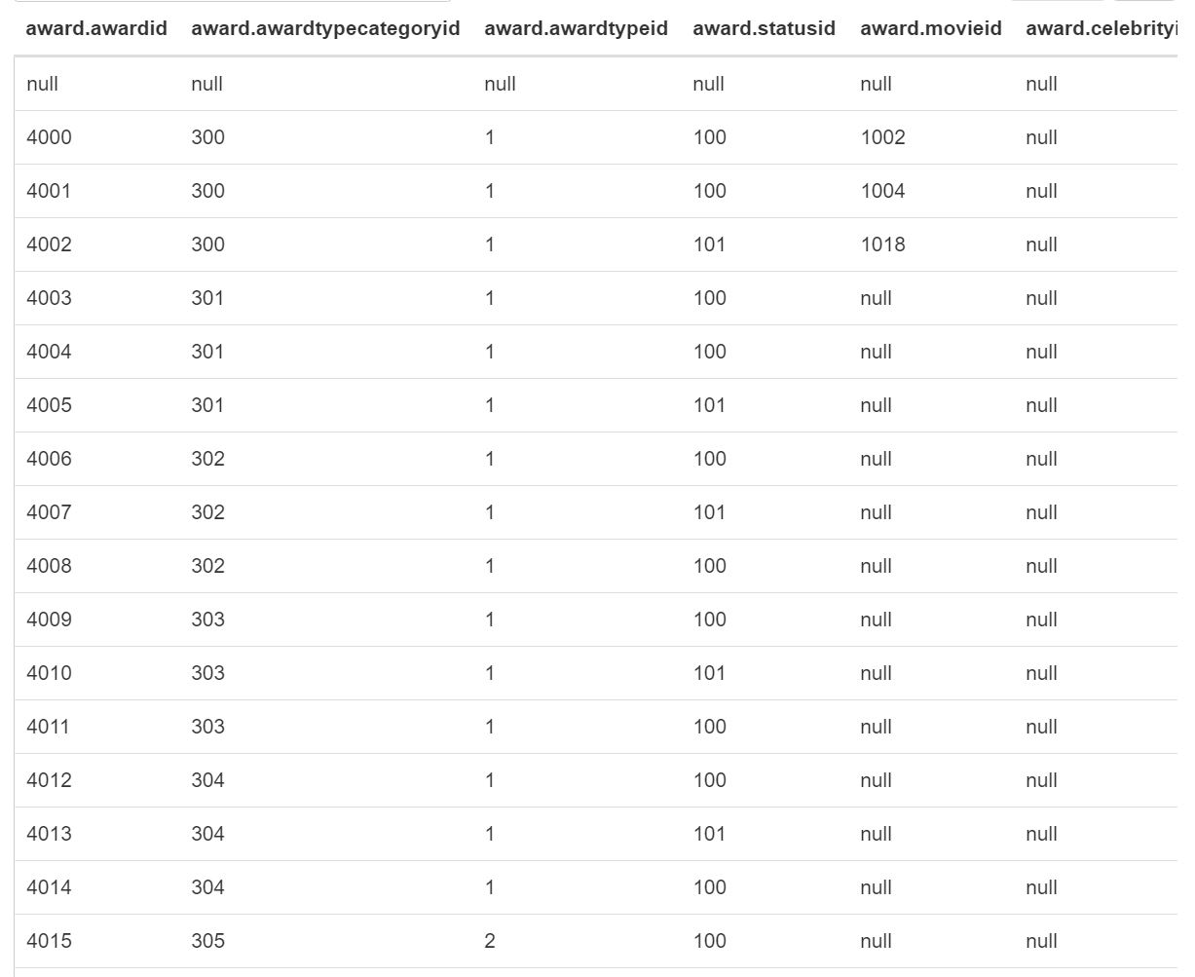

---------------------------------------------------------------------------------------------------------------------

**16. Theatre**

CREATE TABLE Theatre (

TheatreID Int,

AddressID Int,

Name String ,

ModifiedString String ,

ModifiedBy String

)

ROW FORMAT DELIMITED FIELDS

TERMINATED BY ',' STORED AS TEXTFILE;

LOAD DATA INPATH '/user/IMDb/Theatre.csv' OVERWRITE INTO TABLE Theatre;

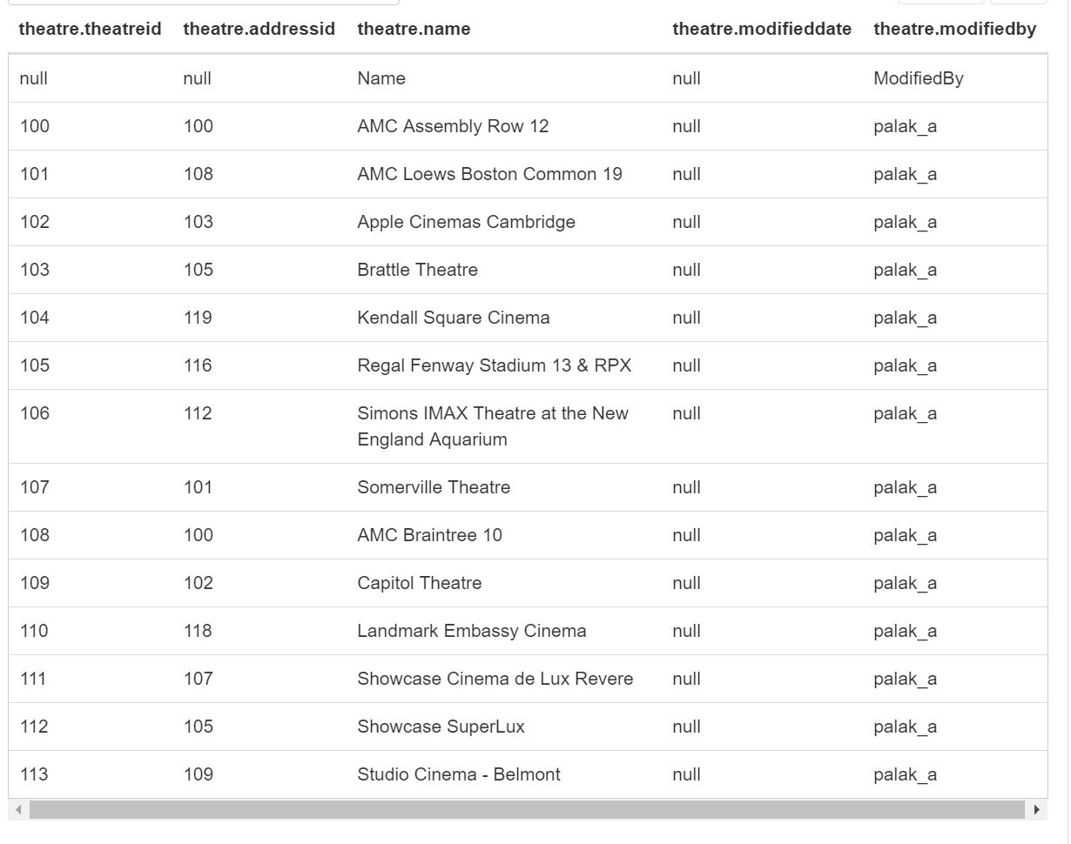

---------------------------------------------------------------------------------------------------------------------

**17. ShowTime**

CREATE TABLE ShowTime (

ShowTimeID Int,

ShowTime String ,

ModifiedString String,

ModifiedBy String

)

ROW FORMAT DELIMITED FIELDS

TERMINATED BY ',' STORED AS TEXTFILE;

LOAD DATA INPATH '/user/IMDb/ShowTime.csv' OVERWRITE INTO TABLE ShowTime;

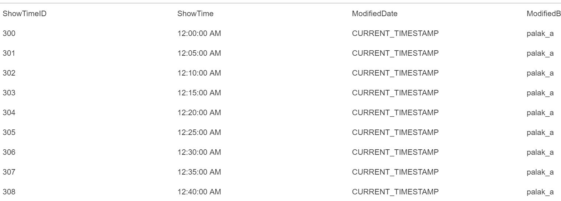

---------------------------------------------------------------------------------------------------------------------

18. **MovieShowInTheatre**

CREATE TABLE MovieShowInTheatre (

MovieID Int,

TheatreID Int,

ScreenID Int,

ShowString String ,

ShowTimeID Int,

ShowPrice String ,

ModifiedString String ,

ModifiedBy String

)

ROW FORMAT DELIMITED FIELDS

TERMINATED BY ',' STORED AS TEXTFILE;

LOAD DATA INPATH '/user/IMDb/MovieShowInTheatre.csv' OVERWRITE INTO TABLE MovieShowInTheatre;

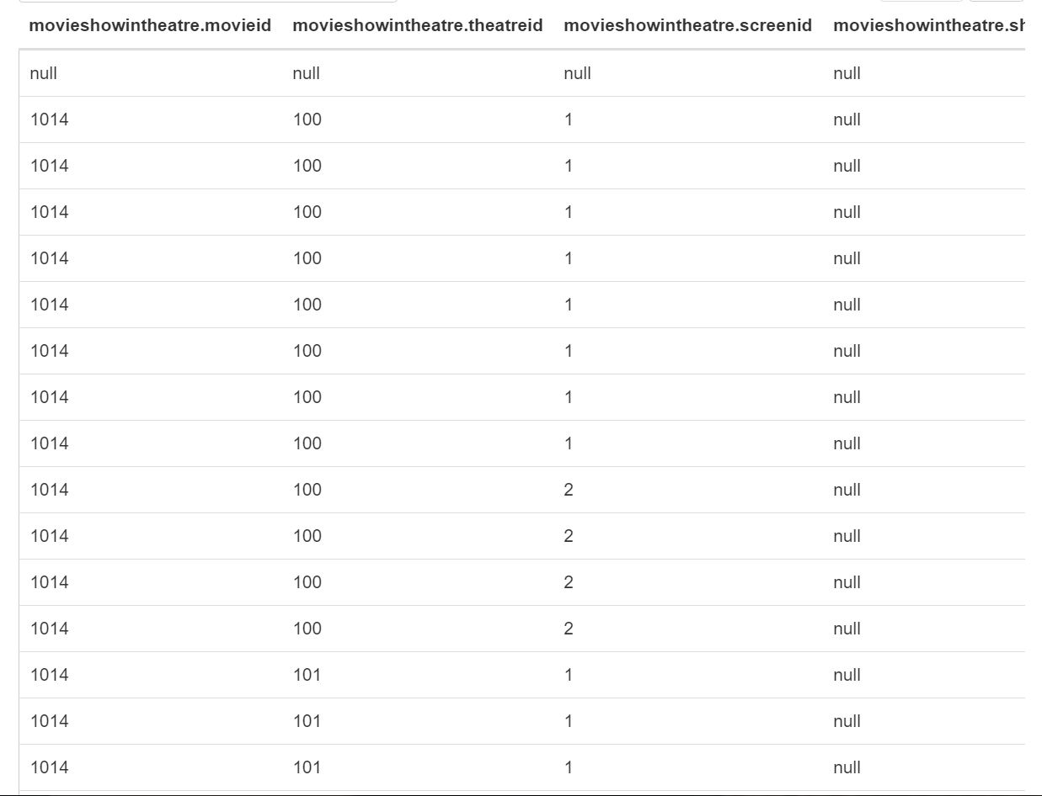

---------------------------------------------------------------------------------------------------------------------

**19. Celebrity**

CREATE TABLE Celebrity (

CelebrityID Int,

Name String ,

BirthString String,

Gender String,

Age Int,

Rating Float,

BirthPlace String,

Height String,

StarSign String,

AlternateName String,

DeathString String,

MiniBioData String,

ModifiedString String ,

ModifiedBy String

)

ROW FORMAT DELIMITED FIELDS

TERMINATED BY ',' STORED AS TEXTFILE;

LOAD DATA INPATH '/user/IMDb/Celebrity.csv' OVERWRITE INTO TABLE Celebrity;

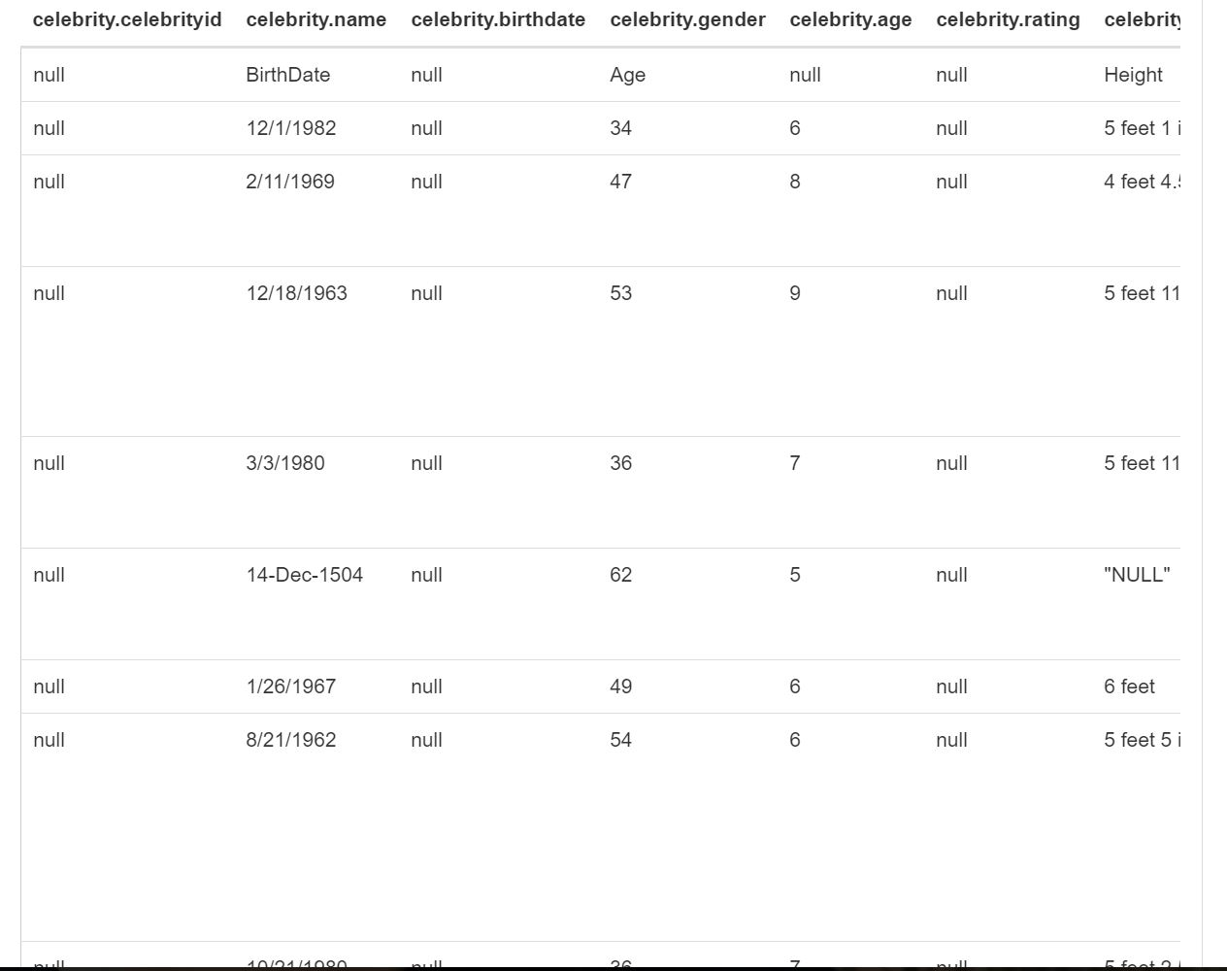

---------------------------------------------------------------------------------------------------------------------

**20. CelebritySpouse**

CREATE TABLE CelebritySpouse (

CelebrityID Int,

SpouseID Int,

NoOfChildren Int,

MarriageString String,

DivorceString String,

ModifiedString String,

ModifiedBy String

)

ROW FORMAT DELIMITED FIELDS

TERMINATED BY ',' STORED AS TEXTFILE;

LOAD DATA INPATH '/user/IMDb/CelebritySpouse.csv' OVERWRITE INTO TABLE CelebritySpouse;

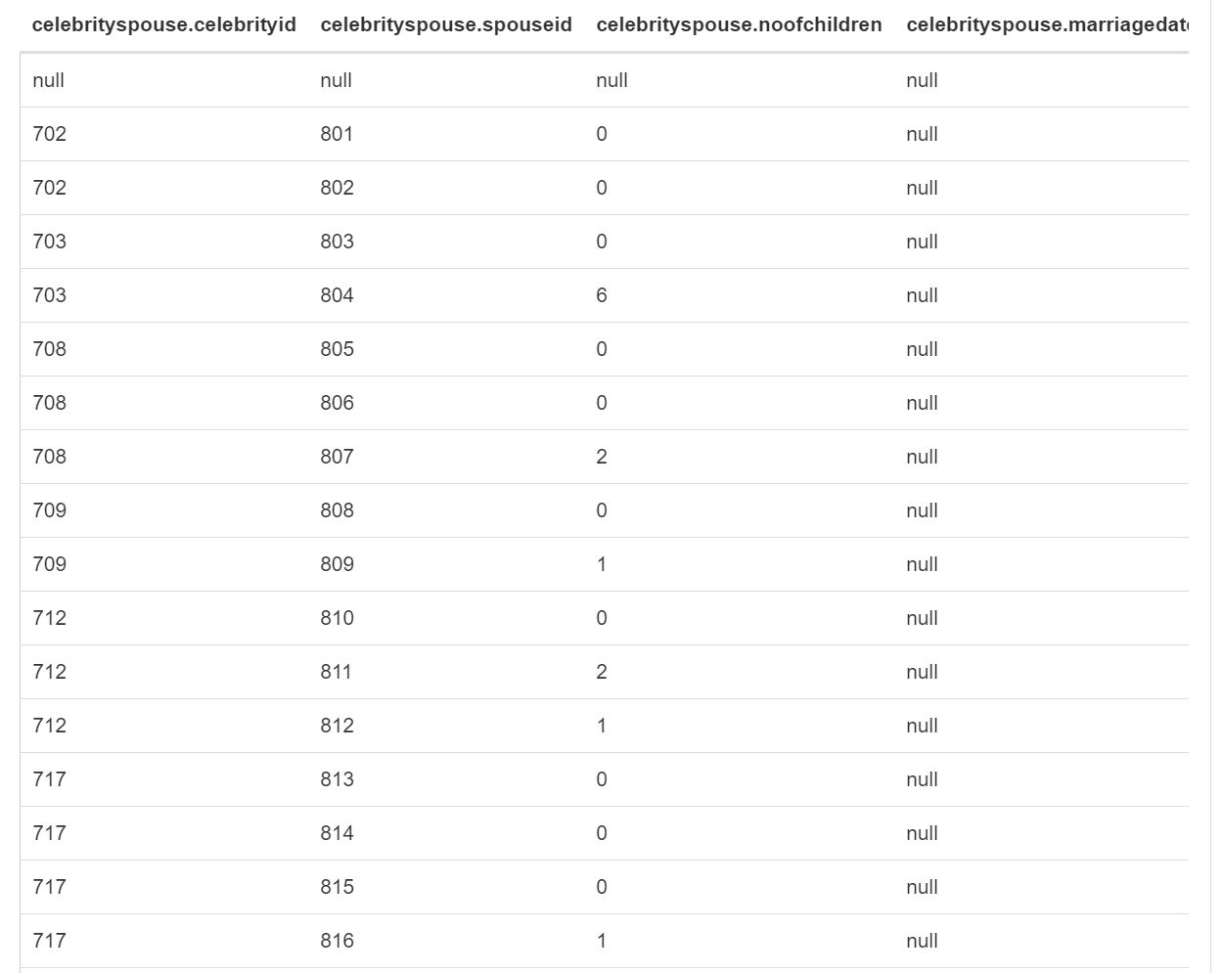

---------------------------------------------------------------------------------------------------------------------

**21. TypeOfCelebrity**

CREATE TABLE TypeOfCelebrity (

TypeID Int,

Type String,

ModifiedString String ,

ModifiedBy String

)

ROW FORMAT DELIMITED FIELDS

TERMINATED BY ',' STORED AS TEXTFILE;

LOAD DATA INPATH '/user/IMDb/TypeOfCelebrity.csv' OVERWRITE INTO TABLE TypeOfCelebrity;

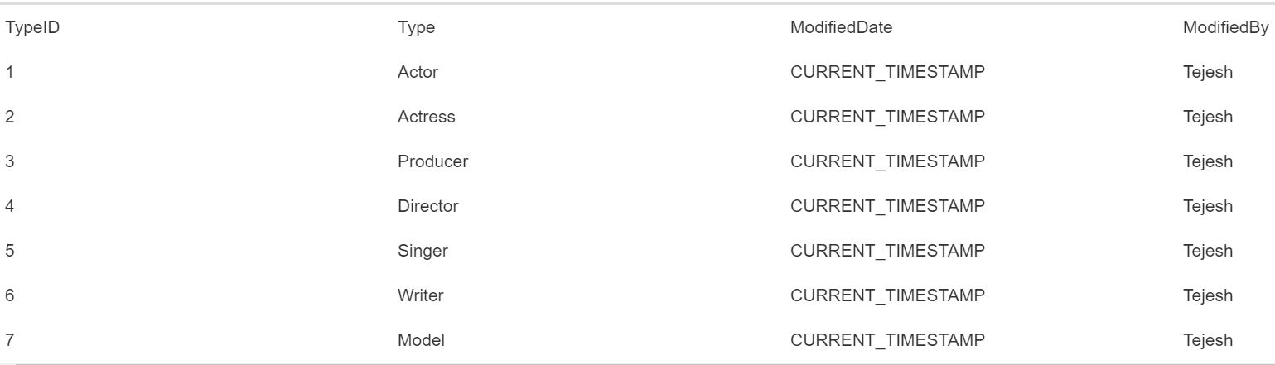

---------------------------------------------------------------------------------------------------------------------

**22. FilmingLocation**

CREATE TABLE FilmingLocation (

LocationID Int,

Location String,

ModifiedString String ,

ModifiedBy String

)

ROW FORMAT DELIMITED FIELDS

TERMINATED BY ',' STORED AS TEXTFILE;

LOAD DATA INPATH '/user/IMDb/FilmingLocation.csv' OVERWRITE INTO TABLE FilmingLocation;

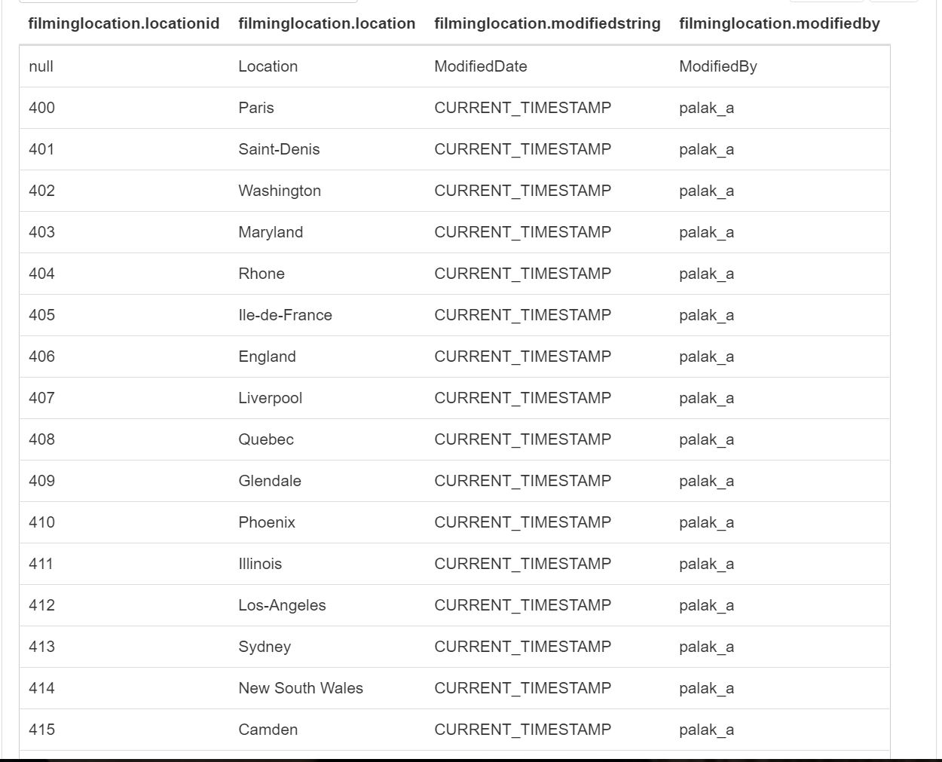

---------------------------------------------------------------------------------------------------------------------

**23. Spouse**

CREATE TABLE Spouse (

SpouseID Int,

SpouseName String,

ModifiedString String ,

ModifiedBy String

)

ROW FORMAT DELIMITED FIELDS

TERMINATED BY ',' STORED AS TEXTFILE;

LOAD DATA INPATH '/user/IMDb/Spouse.csv' OVERWRITE INTO TABLE Spouse;

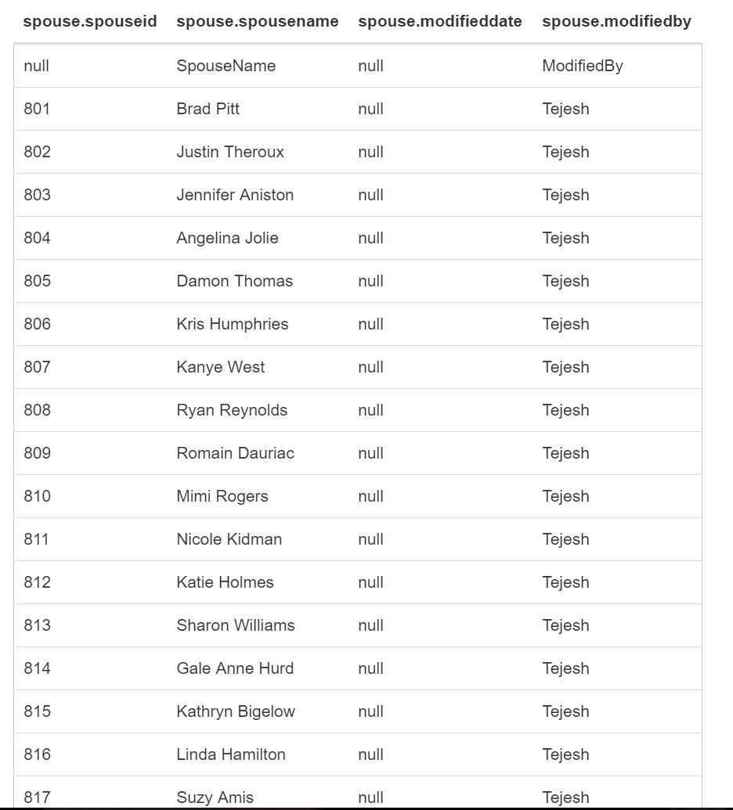

---------------------------------------------------------------------------------------------------------------------

**24. CelebrityType**

CREATE TABLE CelebrityType (

TypeID Int,

CelebrityID Int,

ModifiedString String ,

ModifiedBy String

)

ROW FORMAT DELIMITED FIELDS

TERMINATED BY ',' STORED AS TEXTFILE;

LOAD DATA INPATH '/user/IMDb/CelebrityType.csv' OVERWRITE INTO TABLE CelebrityType;

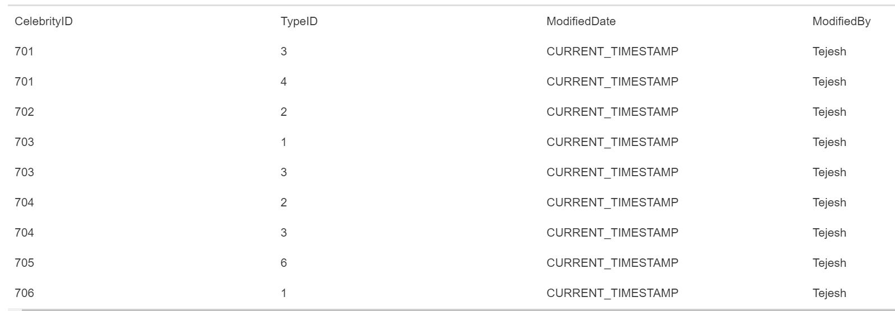

---------------------------------------------------------------------------------------------------------------------

**25. TVShows**

CREATE TABLE TVShows (

TVShowID Int,

StatusID Int,

Name String ,

Rating Float,

Metascore Int,

Vote Int,

Color String,

PrintedFilmFormat String,

NegativeFormat String,

StoryLine String,

AspectRatio String,

ModifiedString String ,

ModifiedBy String

)

ROW FORMAT DELIMITED FIELDS

TERMINATED BY ',' STORED AS TEXTFILE;

LOAD DATA INPATH '/user/IMDb/TVShow.csv' OVERWRITE INTO TABLE TVShows;

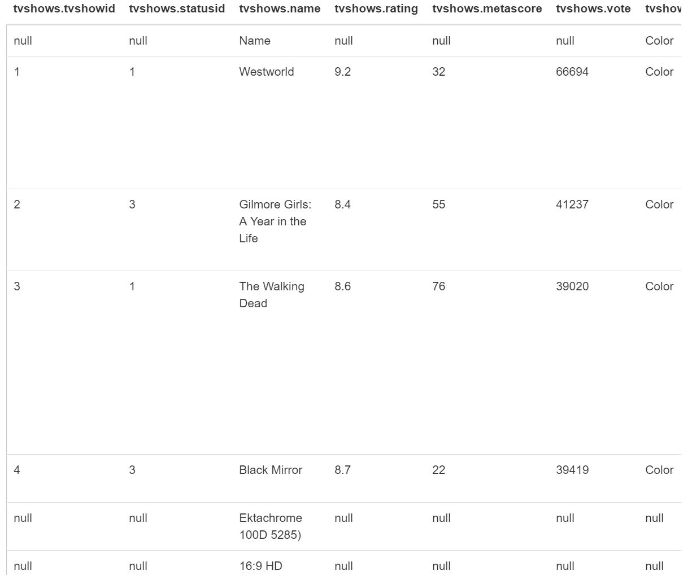

---------------------------------------------------------------------------------------------------------------------

**26. TVCelebrity**

CREATE TABLE TVCelebrity (

TVShowID Int,

TypeID Int,

CelebrityID Int,

ModifiedString String ,

ModifiedBy String

)

ROW FORMAT DELIMITED FIELDS

TERMINATED BY ',' STORED AS TEXTFILE;

LOAD DATA INPATH '/user/IMDb/TVCelebrity.csv' OVERWRITE INTO TABLE TVCelebrity;

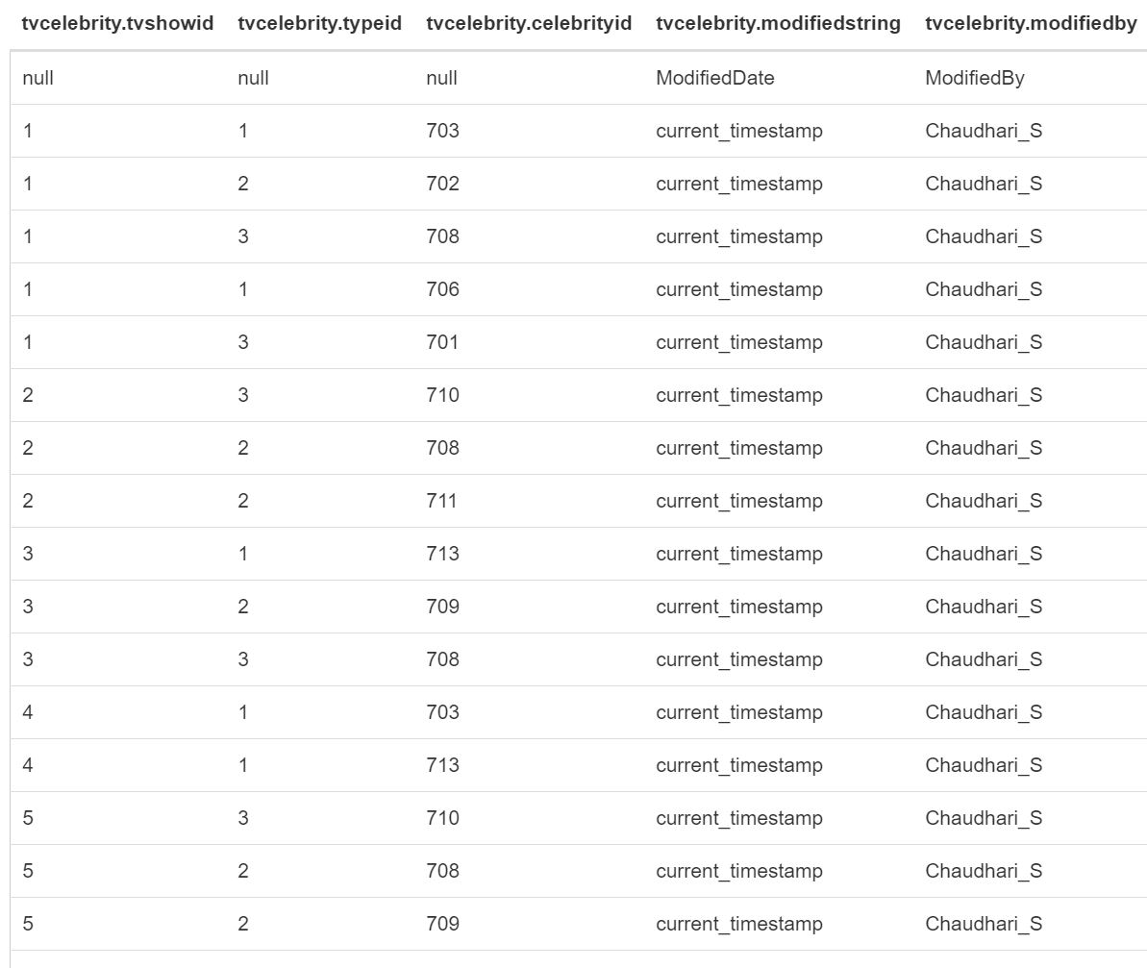

---------------------------------------------------------------------------------------------------------------------

**27. TVSeasonShow**

CREATE TABLE TVSeasonShow (

SeasonID Int,

TVShowID Int,

UserVotes Int,

Rating Float,

SeasonNumber Int,

ModifiedString String ,

ModifiedBy String

)

ROW FORMAT DELIMITED FIELDS

TERMINATED BY ',' STORED AS TEXTFILE;

LOAD DATA INPATH '/user/IMDb/TVShowSeason.csv' OVERWRITE INTO TABLE TVSeasonShow;

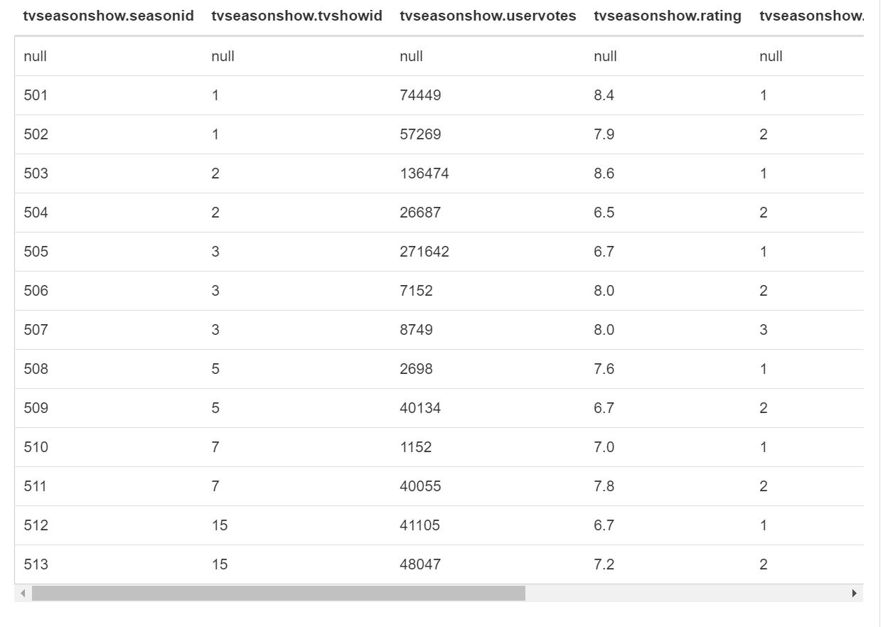

---------------------------------------------------------------------------------------------------------------------

**28. TVShowTime**

CREATE TABLE TVShowTime (

ShowTimeID Int,

ShowTime String ,

ModifiedString String ,

ModifiedBy String

)

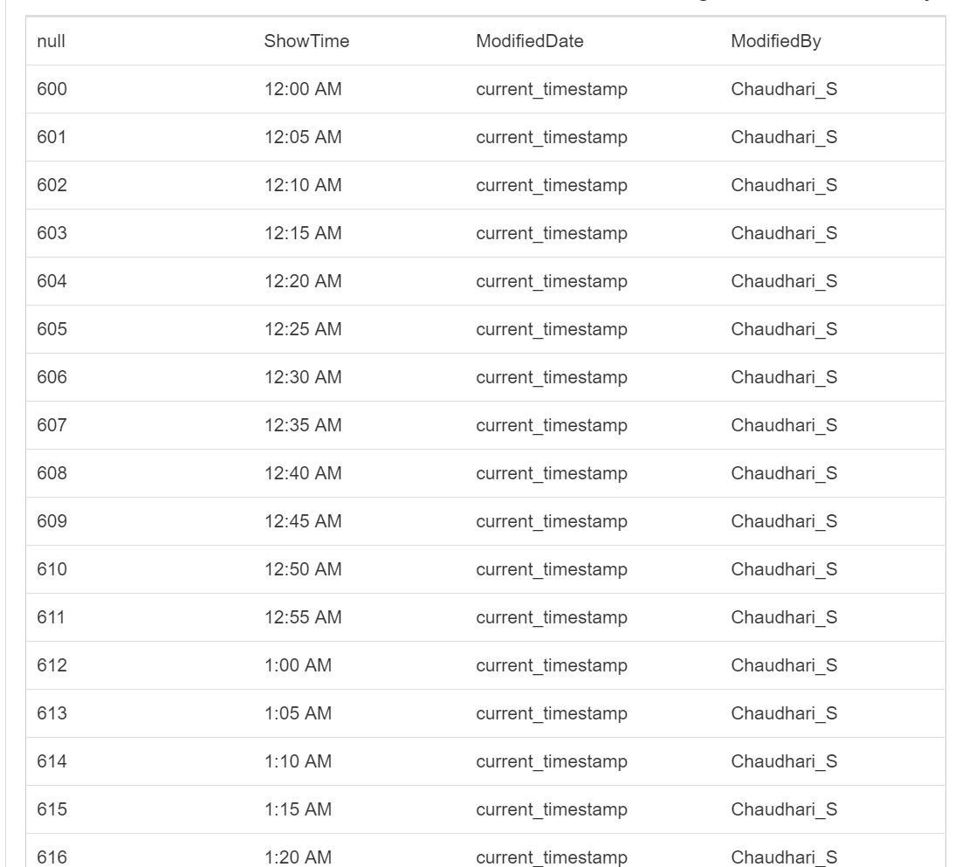

---------------------------------------------------------------------------------------------------------------------

**29. TVShowOnChannel**

CREATE TABLE TVShowOnChannel (

TVShowID Int,

ChannelID Int,

ShowTimeID Int,

ShowString String,

ModifiedString String ,

ModifiedBy String

)

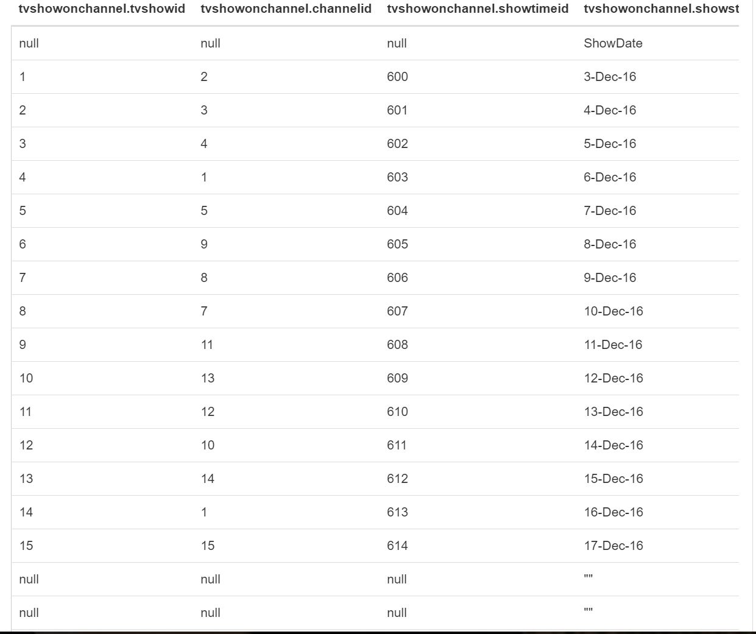

---------------------------------------------------------------------------------------------------------------------

**30. TVShowEpisode**

CREATE TABLE TVShowEpisode (

EpisodeID Int,

EpisodeNumber Int,

UserVotes Int,

Rating Float,

ReleaseString String,

SeasonID Int,

TVShowID Int,

ModifiedString String ,

ModifiedBy String

)

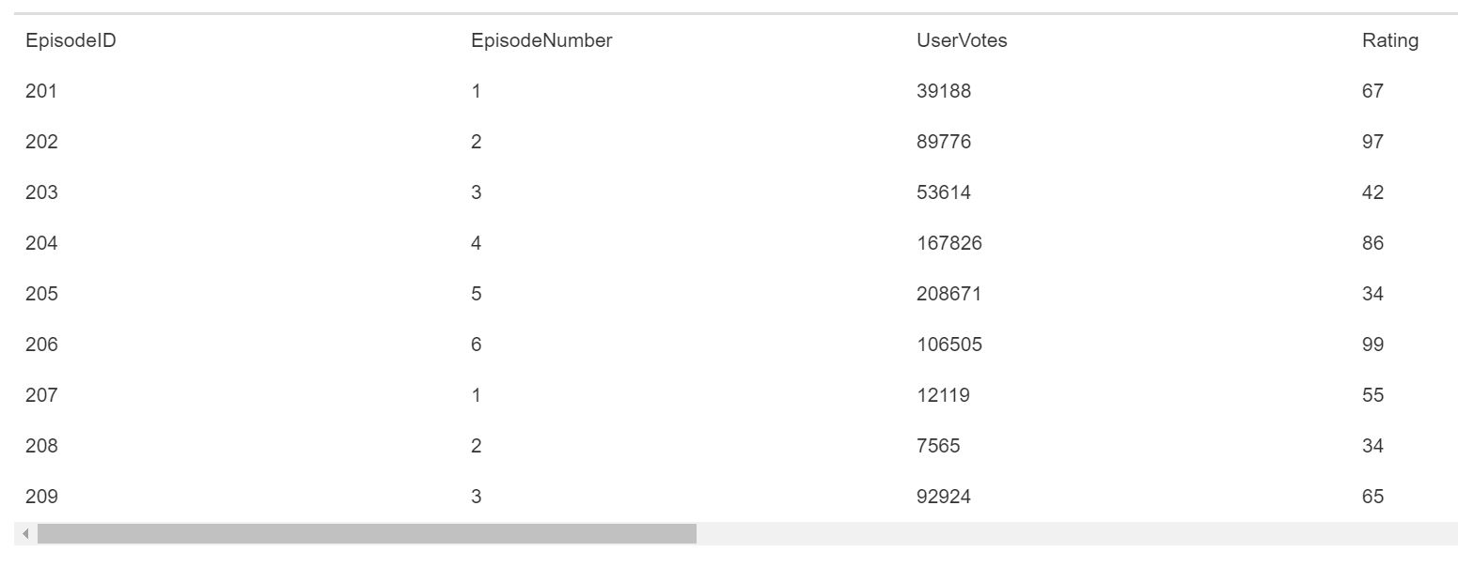

---------------------------------------------------------------------------------------------------------------------

**31. Channel**

CREATE TABLE Channel (

ChannelID Int,

Channel String15 ) ,

ModifiedString String ,

ModifiedBy String

)

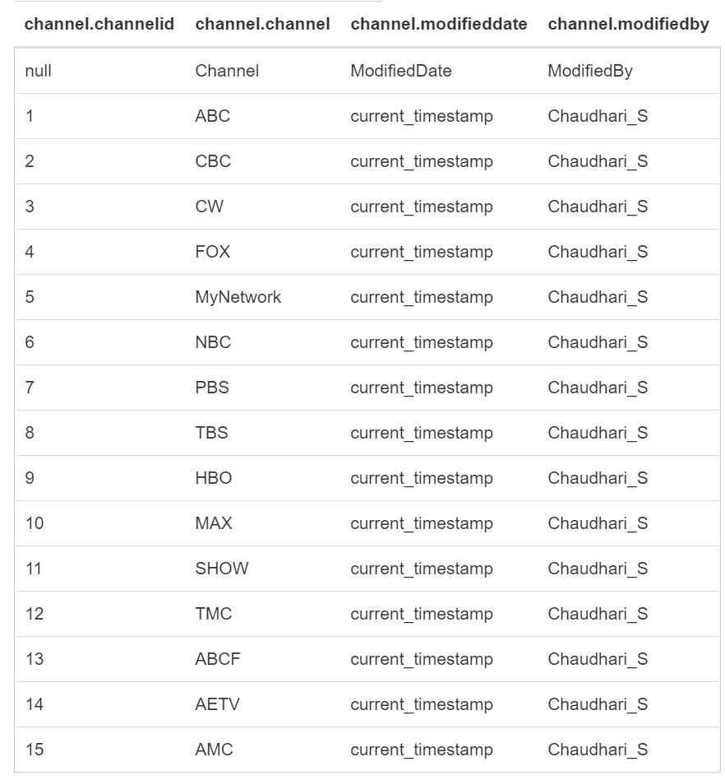

**32. ShowDate**

CREATE TABLE ShowDate (

ShowString String ,

DayOfWeek String,

ModifiedString String ,

ModifiedBy String

)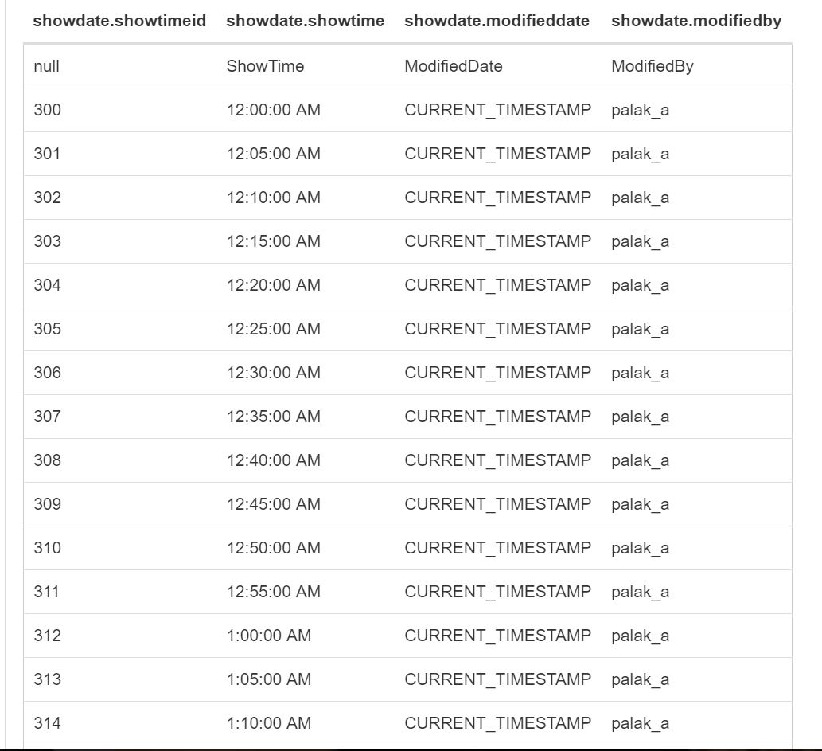

---------------------------------------------------------------------------------------------------------------------

**33. MovieCelebrity**

CREATE TABLE MovieCelebrity (

MovieID Int,

TypeID Int,

CelebrityID Int,

ModifiedString String ,

ModifiedBy String

)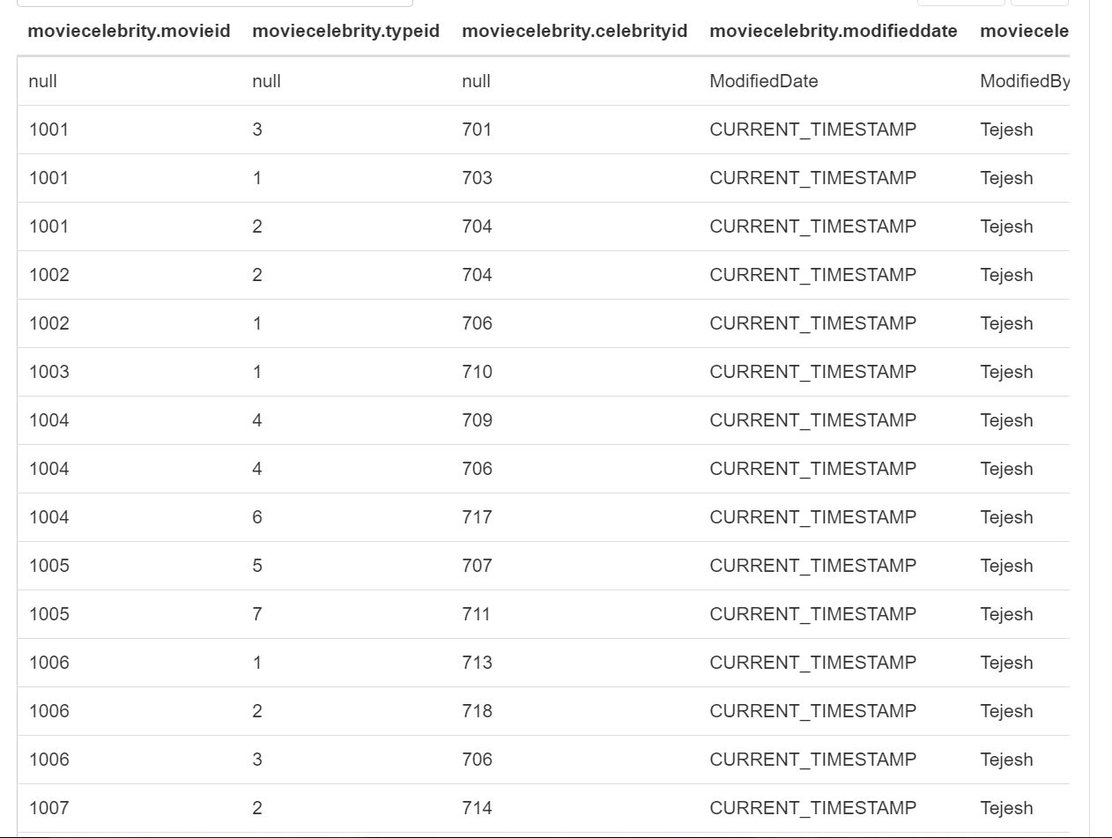

--------------------------------------------------------------------------------------------------------------------

**34. DiskTypeRef**

CREATE TABLE DiskTypeRef (

DiskTypeID Int,

DiskType String ,

ModifiedString String ,

ModifiedBy String

)

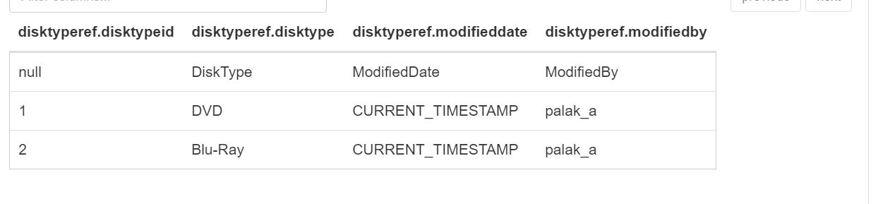

---------------------------------------------------------------------------------------------------------------------

**35. Editor**

CREATE TABLE Editor (

EditorID Int,

EditorName String ,

ModifiedString String ,

ModifiedBy String

)

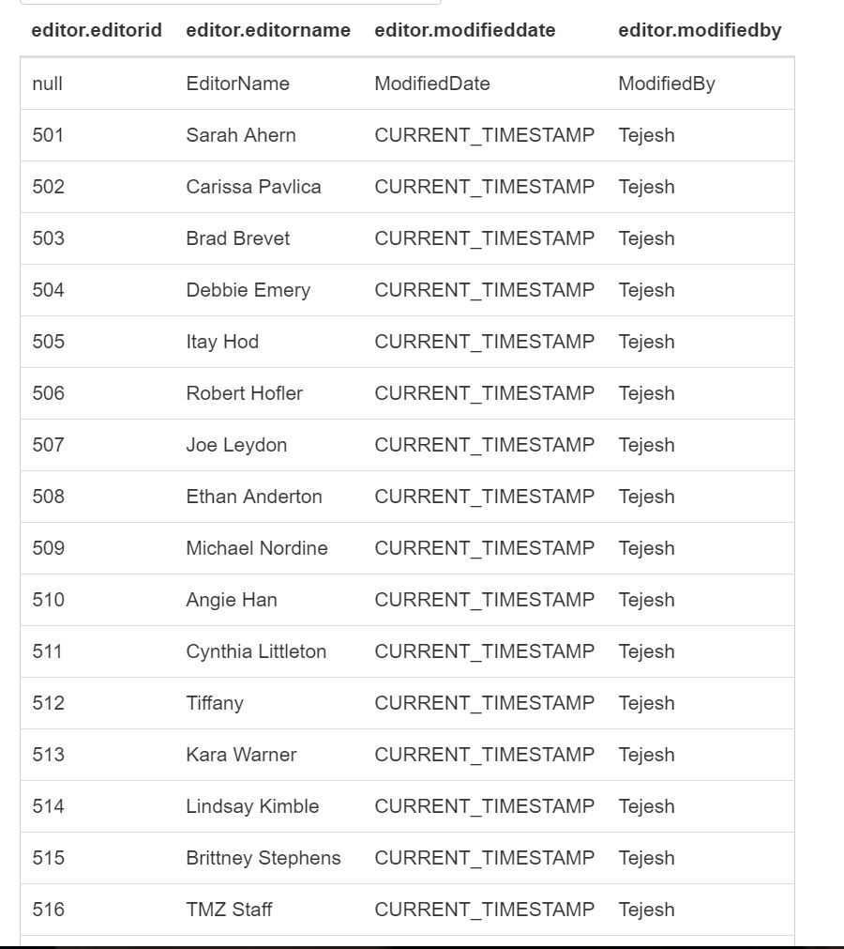

---------------------------------------------------------------------------------------------------------------------

**36. CelebrityNews**

CREATE TABLE CelebrityNews (

CelebrityNewsID Int,

EditorID Int,

CelebrityID Int,

NewsTitle String ,

News String1 ,

UserVote Int,

ModifiedString String ,

ModifiedBy String

)

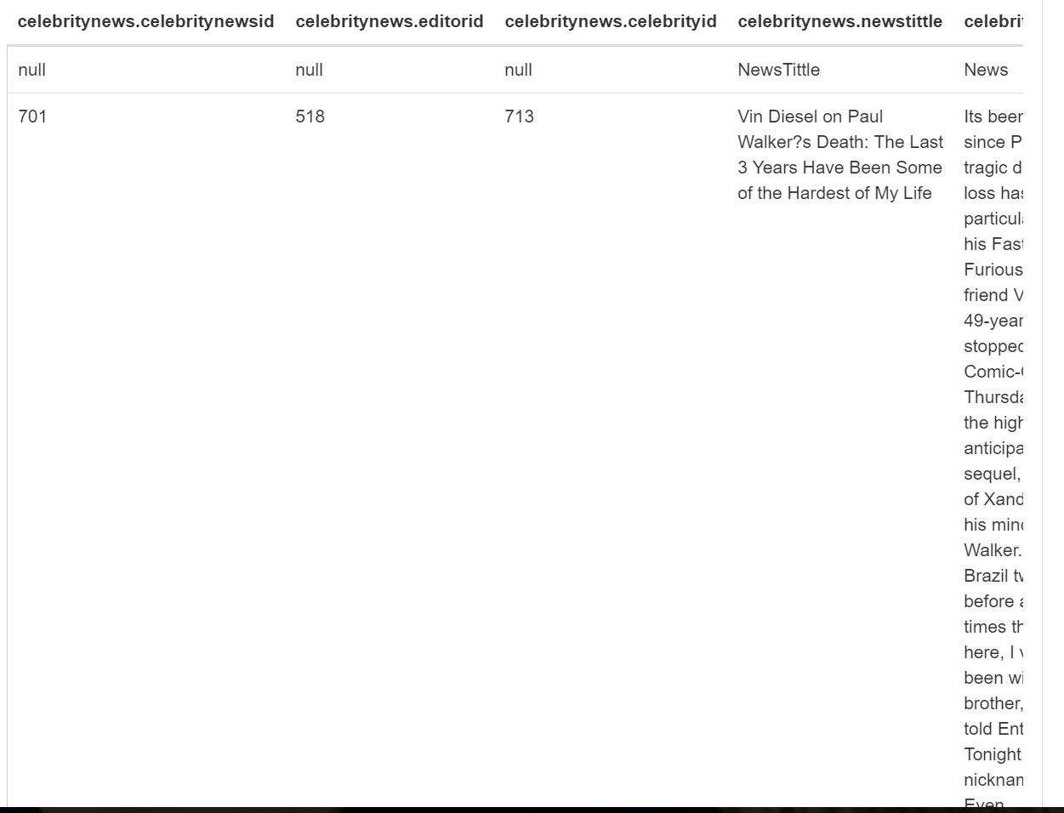

---------------------------------------------------------------------------------------------------------------------

**37. MovieNews**

CREATE TABLE MovieNews (

MovieNewsID Int,

EditorID Int,

MovieID Int,

NewsTitle String ,

News String1 ,

UserVotes Int,

ModifiedString String ,

ModifiedBy String

)

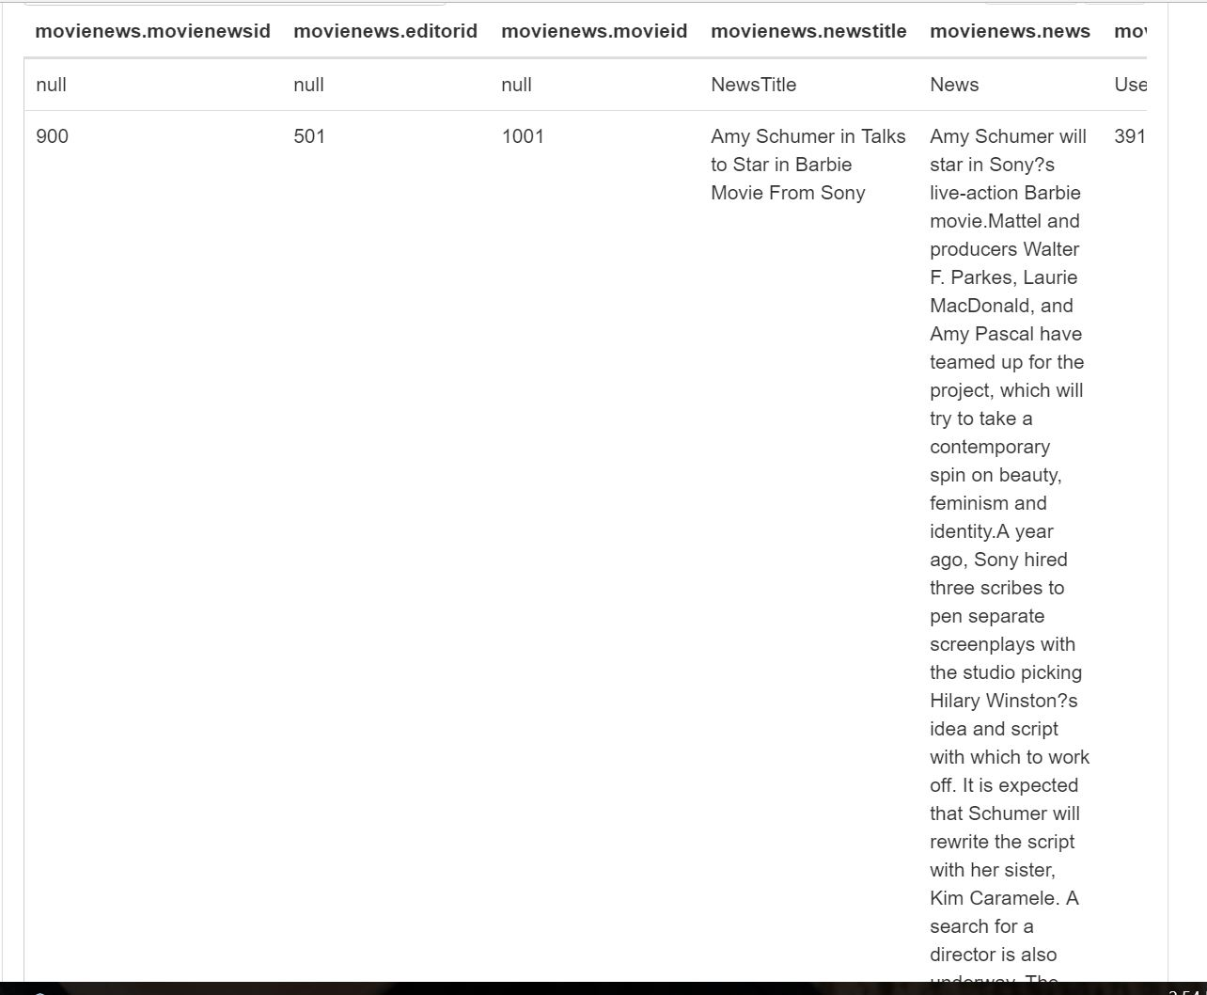

---------------------------------------------------------------------------------------------------------------------

**38. TVNews**

CREATE TABLE TVNews (

TVShowNewsID Int,

EditorID Int,

TVShowID Int,

NewsTitle String ,

News String1 ,

UserVotes Int,

ModifiedString String ,

ModifiedBy String

)

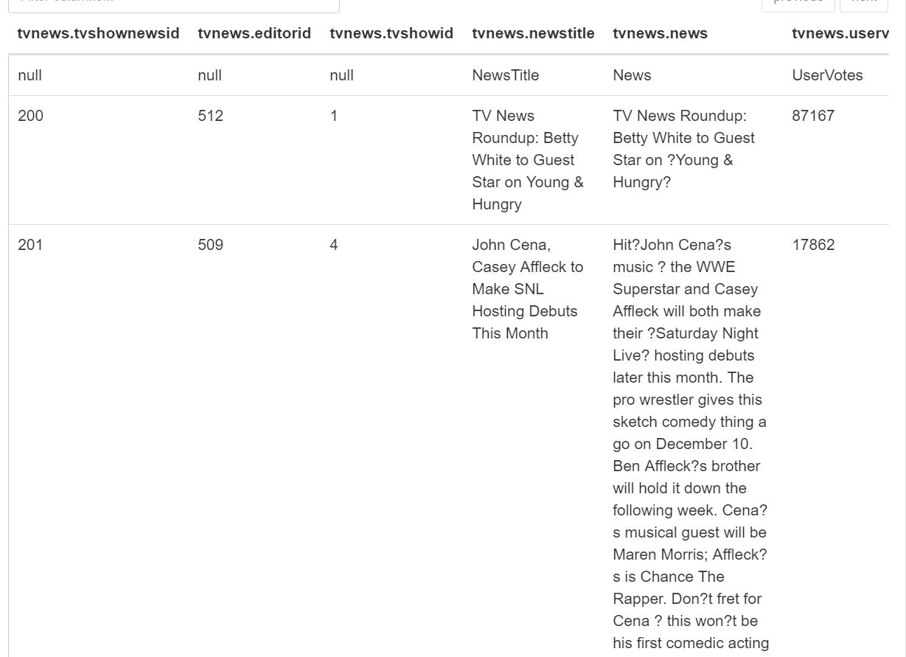

---------------------------------------------------------------------------------------------------------------------

**39. UserPoll**

CREATE TABLE UserPoll (

PollQuestionID Int,

OptionID Int,

UserID Int,

ModifiedString String ,

ModifiedBy String

)

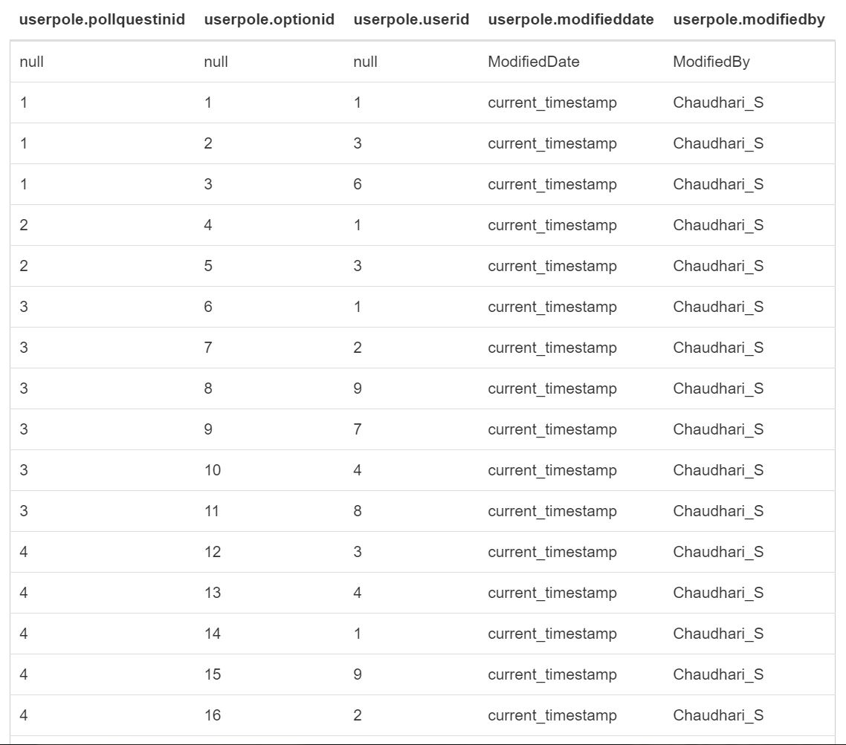

---------------------------------------------------------------------------------------------------------------------

**40. PollQuestion**

CREATE TABLE PollQuestion (

PollQuestionID Int,

PostedBy String,

PostedOn String ,

UserVotes Int,

Question String ,

ModifiedString String ,

ModifiedBy String

)

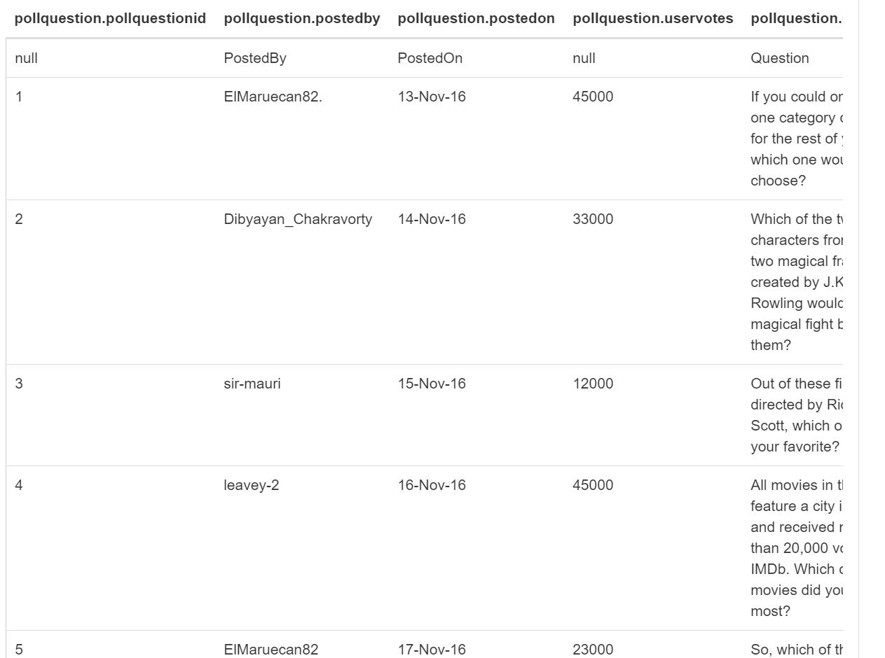

---------------------------------------------------------------------------------------------------------------------

**41. NewsChannel**

CREATE TABLE NewsChannel (

NewsChannelID Int,

NewsChannelName String ,

ModifiedString String ,

ModifiedBy String ,

StringOfCreation String

)

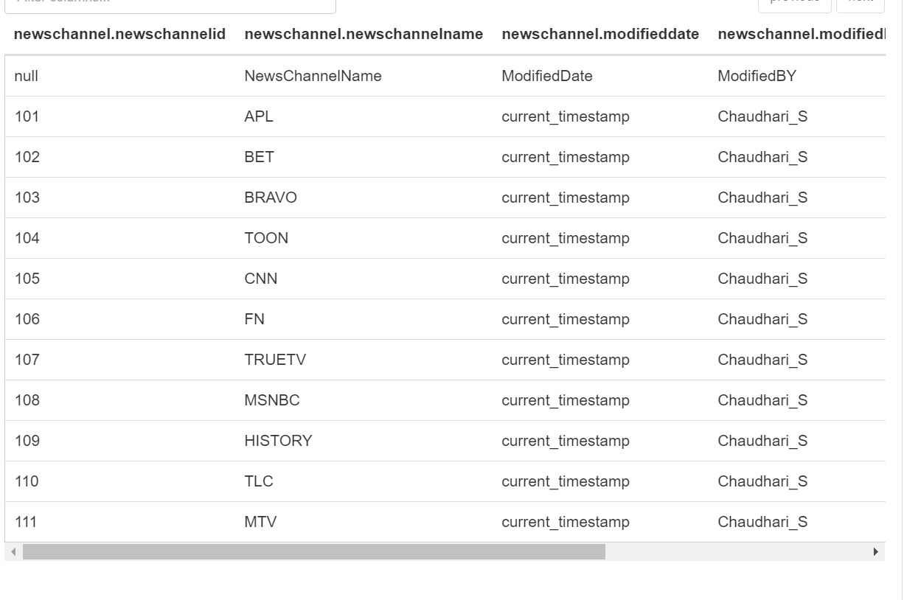

---------------------------------------------------------------------------------------------------------------------

**42. IndieNews**

CREATE TABLE IndieNews (

IndieNewsID Int,

EditorID Int,

NewsTitle String ,

News String1 ,

UserVotes Int,

ModifiedString String ,

ModifiedBy String

)

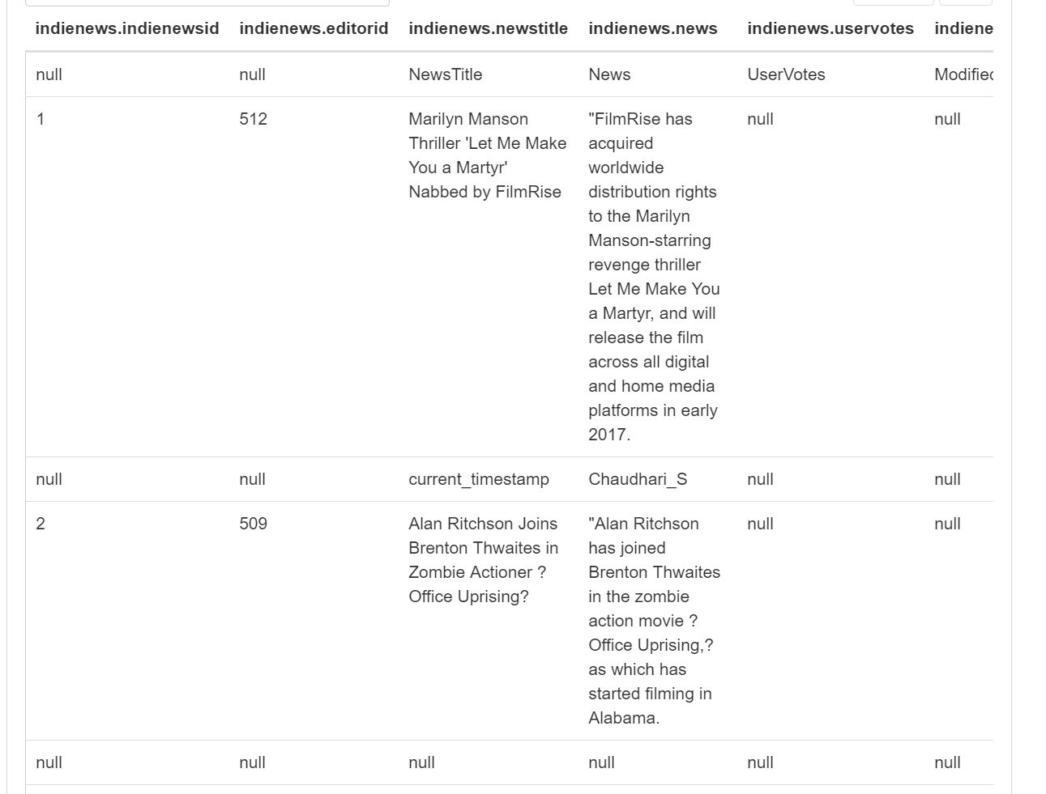

---------------------------------------------------------------------------------------------------------------------

**43. MovieOrTVDiskType**

CREATE TABLE MovieOrTVDiskType (

DiskTypeID Int,

MovieID Int,

TVShowID Int,

ModifiedString String ,

ModifiedBy String

)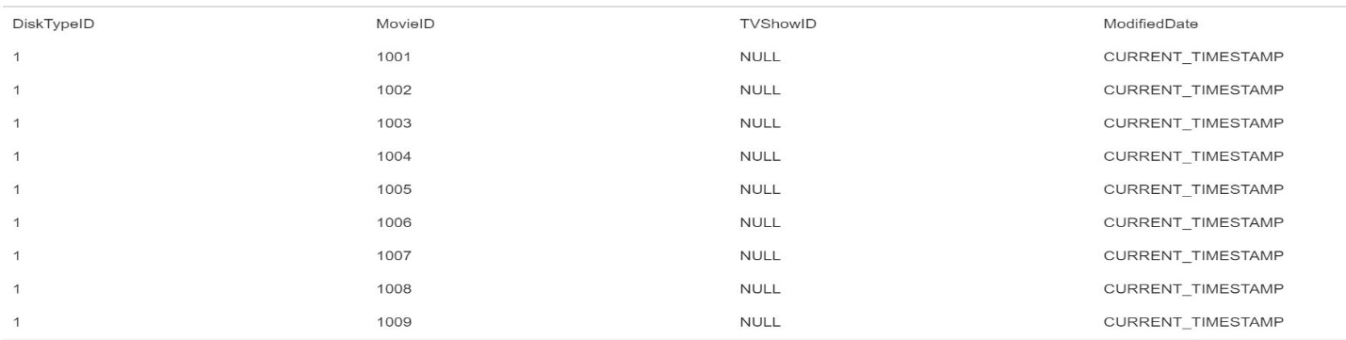

---------------------------------------------------------------------------------------------------------------------

**44. NewsOnChannel**

CREATE TABLE NewsOnChannel (

NewsChannelID Int,

MovieNewsID Int,

CelebrityNewsID Int,

TVShowNewsID Int,

IndieNewsID Int,

StringAndTimeOfNews String ,

ModifiedString String ,

ModifiedBy String

)



---------------------------------------------------------------------------------------------------------------------

**46. Address**

CREATE TABLE Address (

AddressID Int,

AddressLn1 String ,

AddressLn2 String,

PostalCode Int,

CityID Int,

ModifiedString String ,

ModifiedBy String

)

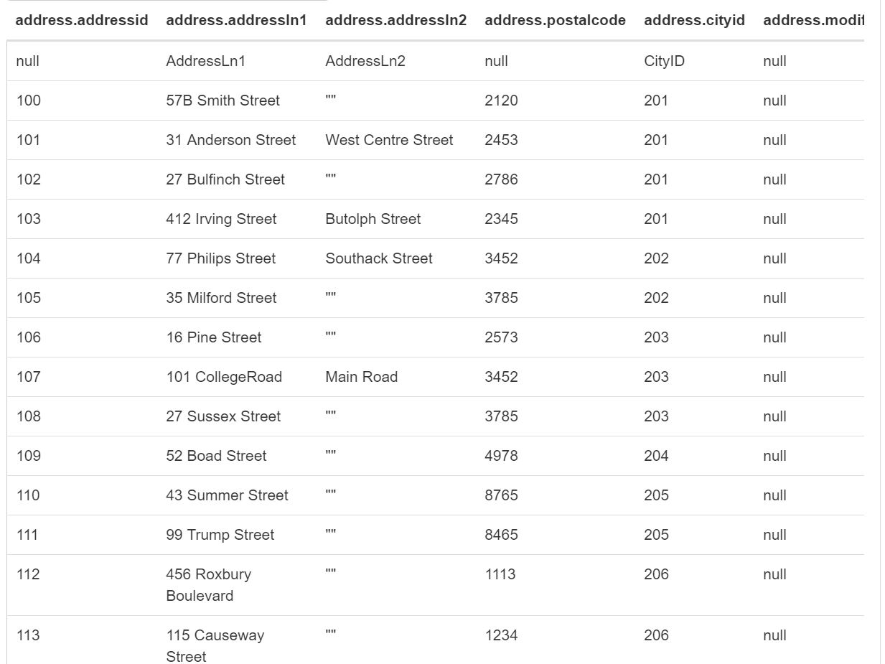

---------------------------------------------------------------------------------------------------------------------

**47. StateProvince**

CREATE TABLE StateProvince (

StateProvinceID Int,

StateName String ,

CountryID Int,

ModifedString String ,

ModifiedBy String

)

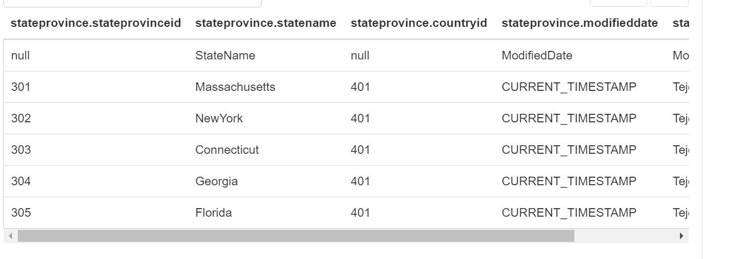

---------------------------------------------------------------------------------------------------------------------

**48. City**

CREATE TABLE City (

CityID Int,

CityName String ,

StateProvinceID Int,

ModifiedString String ,

ModifiedBy String

)

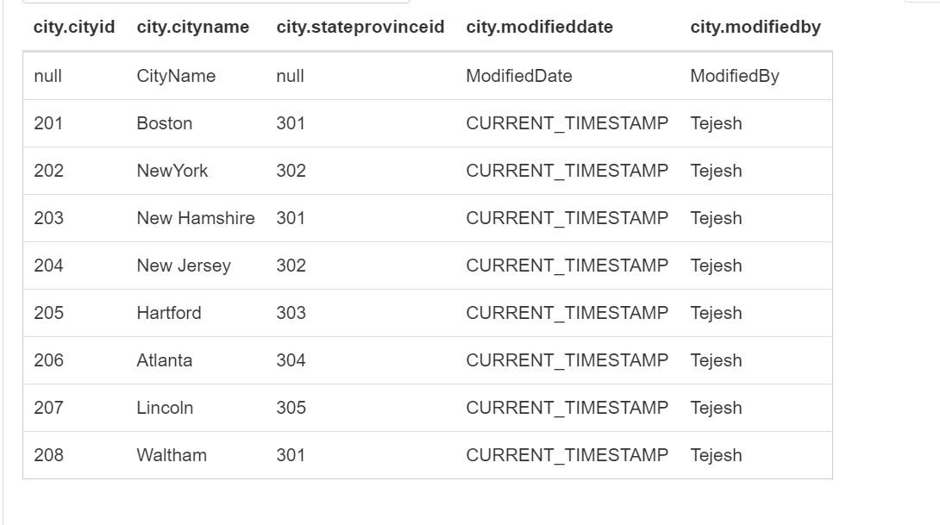

**49. Country**

CREATE TABLE Country (

CountryID Int,

CountryName String ,

ModifiedString String ,

ModifiedBy String

)

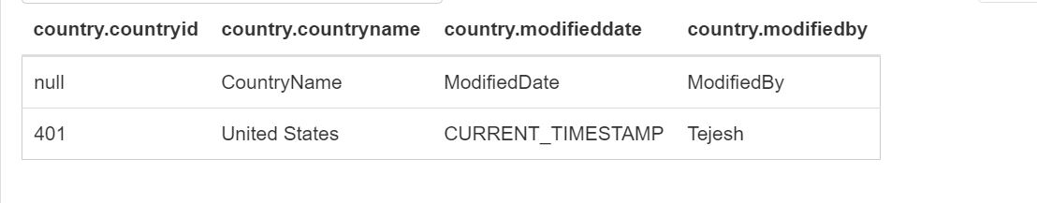

---------------------------------------------------------------------------------------------------------------------

**50. EmailAddress**

CREATE TABLE EmailAddress (

EmailAddressID Int,

PersonID Int,

EmailAddress String,

ModifiedString String ,

ModifiedBy String

)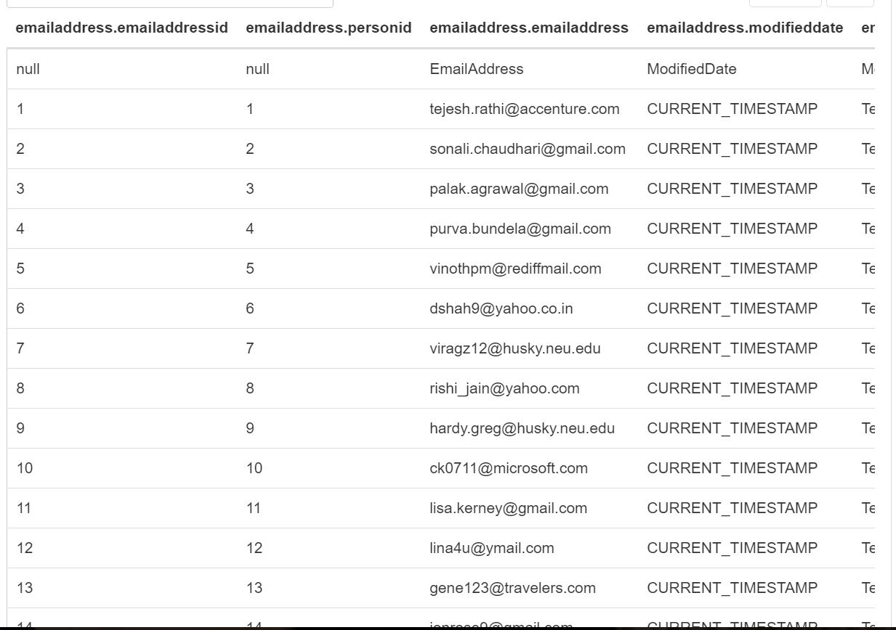

---------------------------------------------------------------------------------------------------------------------

**51. Phone**

CREATE TABLE Phone (

PhoneID Int,

PersonID Int,

PhoneNumber String,

ModifiedString String ,

ModifiedBy String

)

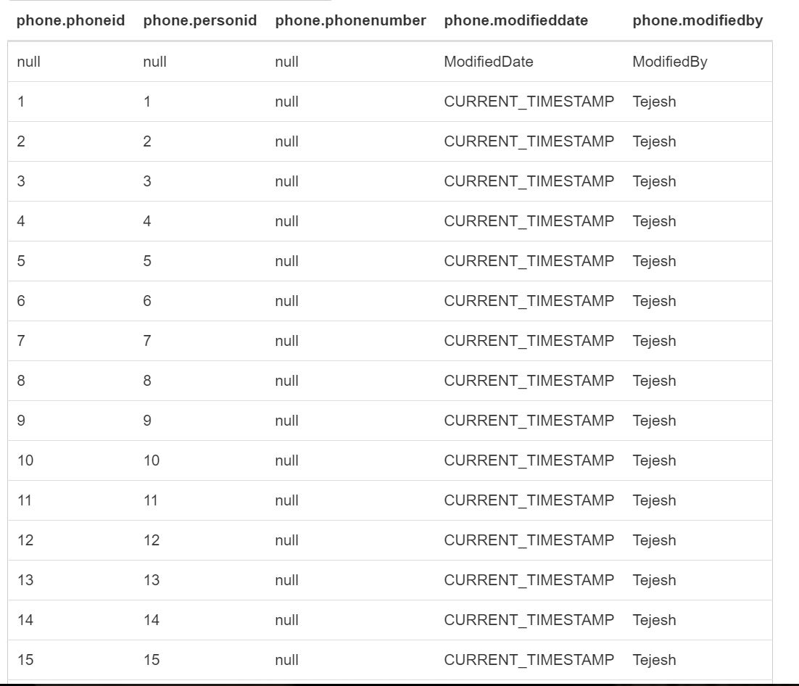

---------------------------------------------------------------------------------------------------------------------

**52. Critics**

CREATE TABLE Critics (

CriticsID Int,

PersonID Int,

ModifiedString String ,

ModifiedBy String

)

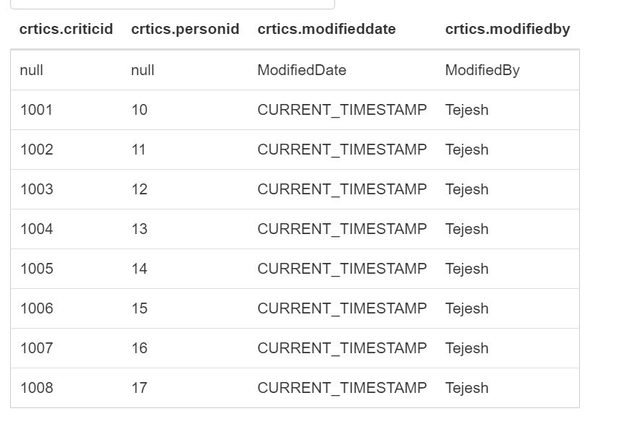

---------------------------------------------------------------------------------------------------------------------

**53. PersonAccount**

CREATE TABLE PersonAccount (

PersonID Int,

UserName String ,

AccountNumber String ,

Password String ,

CreateString String ,

ModifiedString String ,

ModifiedBy String

)

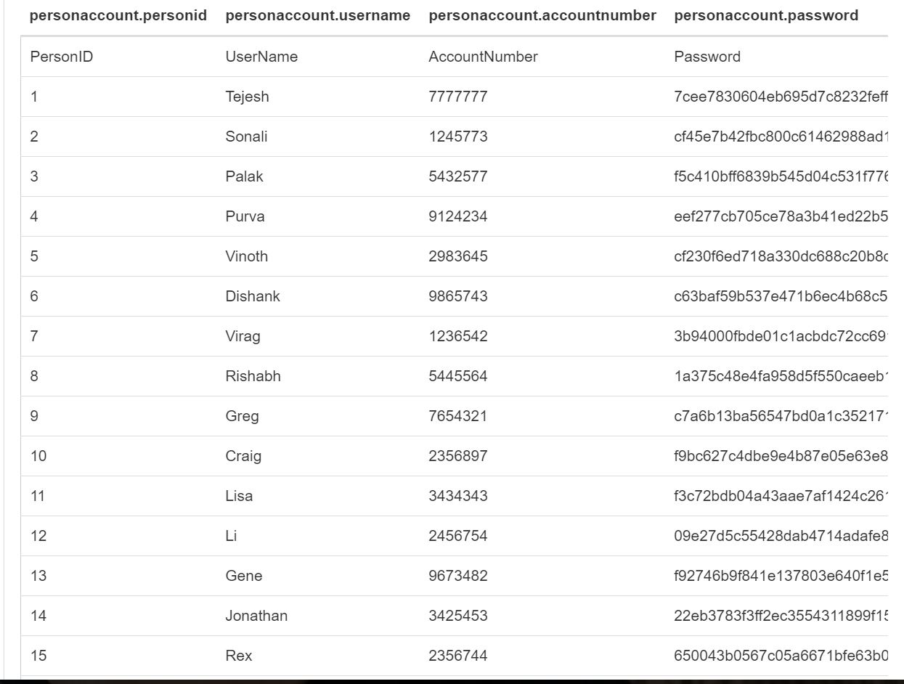

---------------------------------------------------------------------------------------------------------------------

**54. User**

CREATE TABLE User (

UserID Int,

PersonID Int,

ModifiedString String ,

ModifiedBy String

)

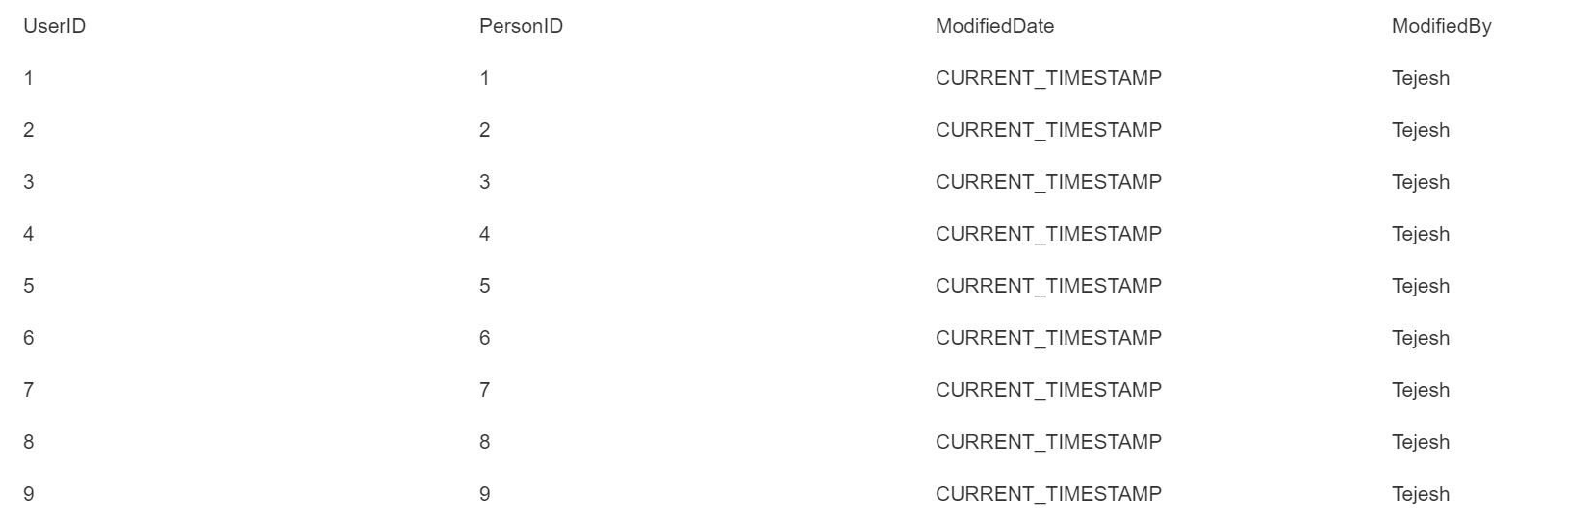

---------------------------------------------------------------------------------------------------------------------

**55. AgeType**

CREATE TABLE AgeType (

AgeRangeID Int,

AgeType String ,

AgeRange String ,

ModifiedString String ,

ModifiedBy String

)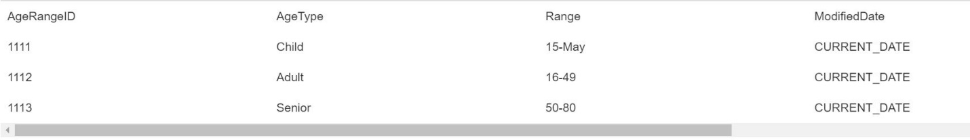

---------------------------------------------------------------------------------------------------------------------

**56. Person**

CREATE TABLE Person (

PersonID Int,

AddressID Int,

AgeRangeID Int,

FirstName String,

LastName String ,

Gender String,

PersonType String,

Age Int,

ModifiedString String ,

ModifiedBy String

)

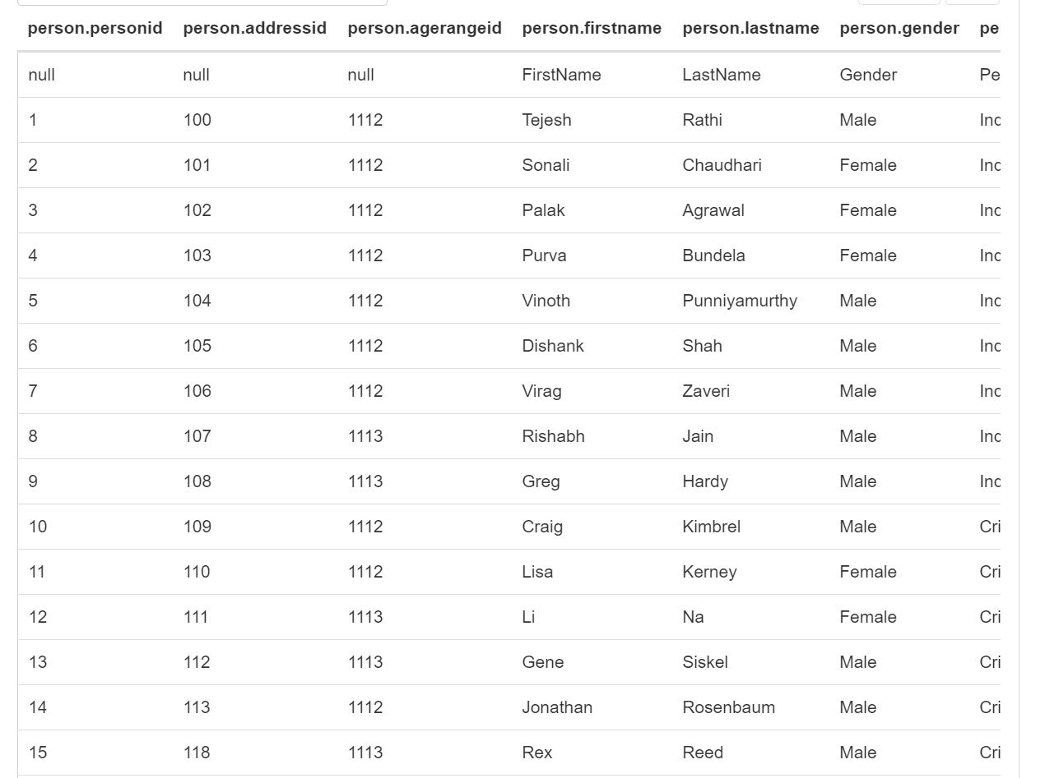

---------------------------------------------------------------------------------------------------------------------

**57. MessageBoard**

CREATE TABLE MessageBoard (

DiscussionID Int,

TopicID Int,

DiscussionContent String ,

ModifiedString String ,

ModifiedBy String ,

UserID Int

)

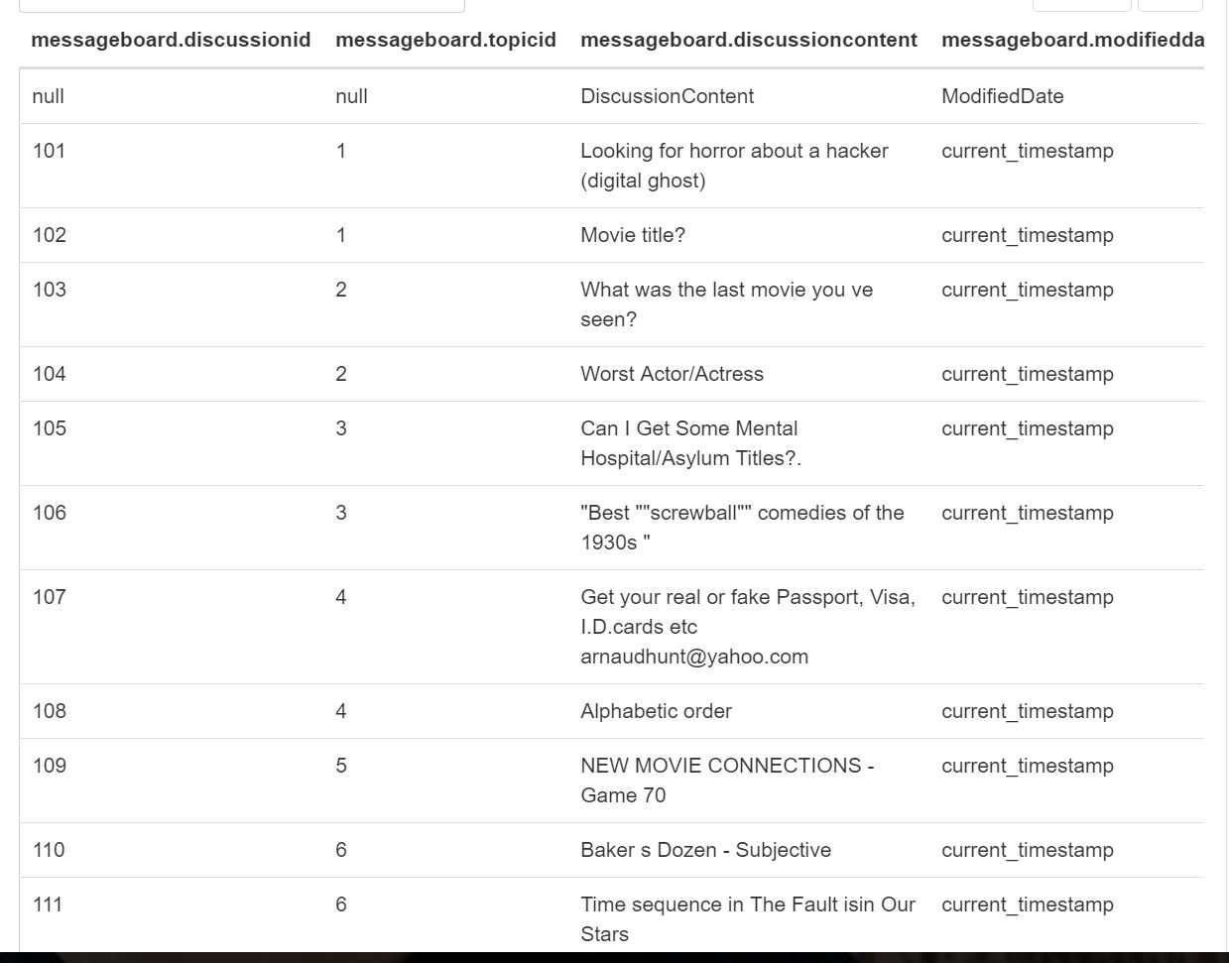

---------------------------------------------------------------------------------------------------------------------

**58. MessageBoardCategory**

CREATE TABLE MessageBoardCategory (

CategoryID Int,

CategoryName String ,

ModifiedString String ,

ModifiedBy String

)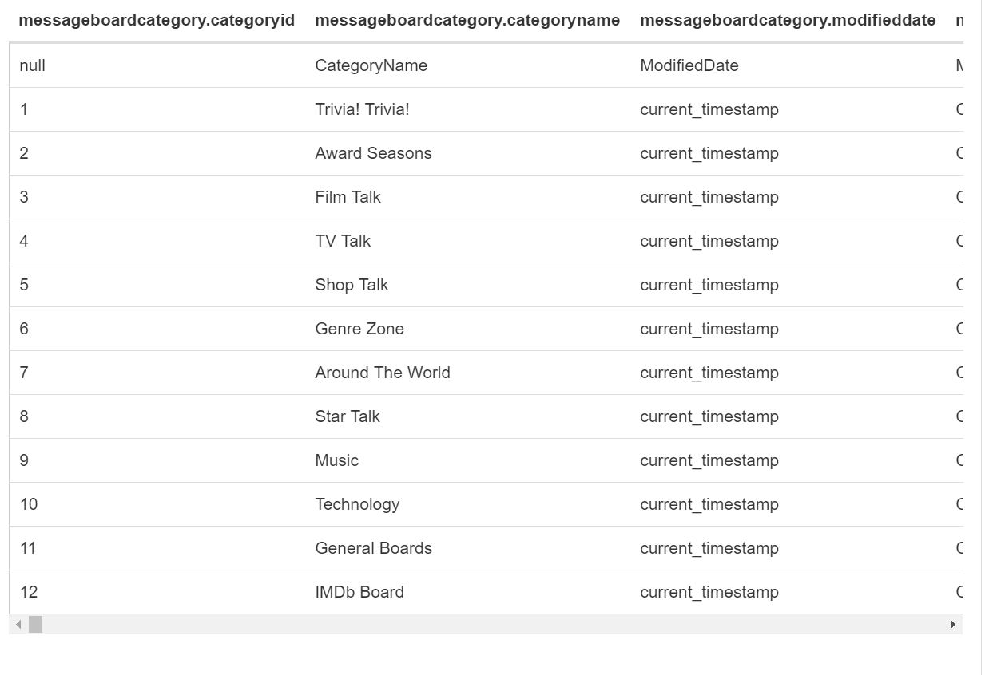

---------------------------------------------------------------------------------------------------------------------

**59. MessageBoardTopic**

CREATE TABLE MessageBoardTopic (

TopicID Int,

CategoryID Int,

TopicName String ,

TopicStartString String ,

ModifiedString String ,

ModifiedBy String

)

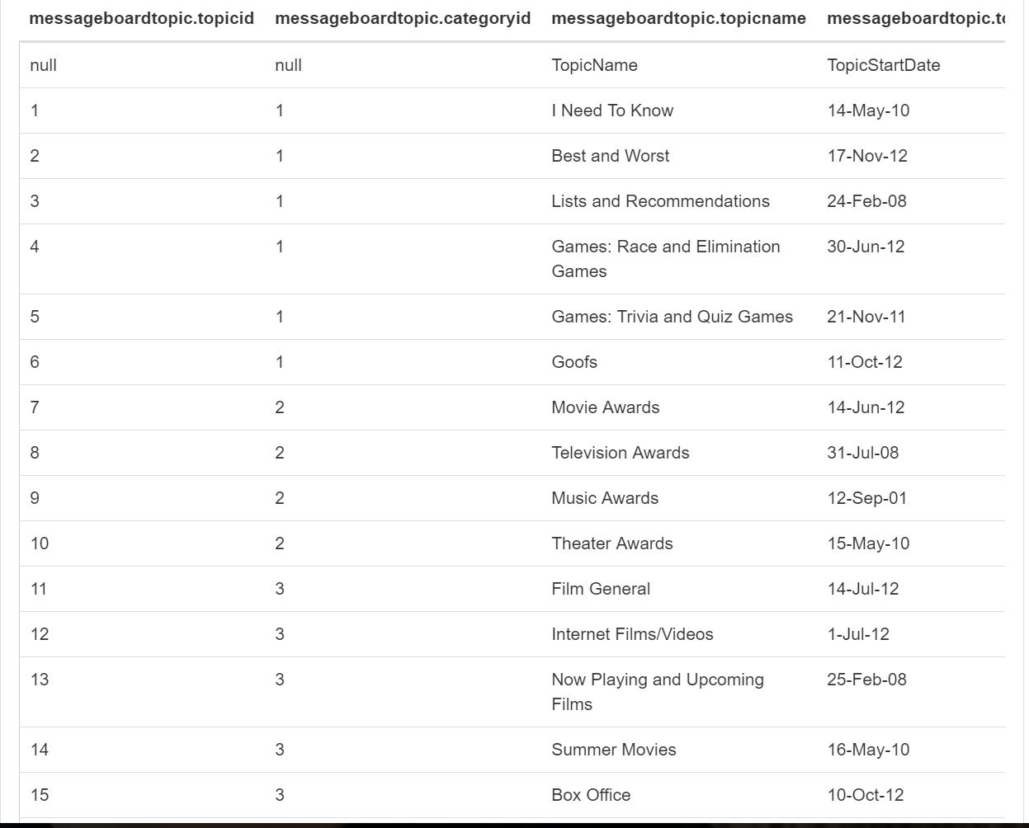

---------------------------------------------------------------------------------------------------------------------

**60. UserBooking**

CREATE TABLE UserBooking (

BookingID Int,

MovieID Int,

ShowString String ,

ShowTimeID Int,

PersonID Int,

TicketCount Int,

TotalPrice Float ,

StringOfBooking String ,

ModifiedString String ,

ModifiedBy String ,

TheatreID Int,

ScreenID Int

)

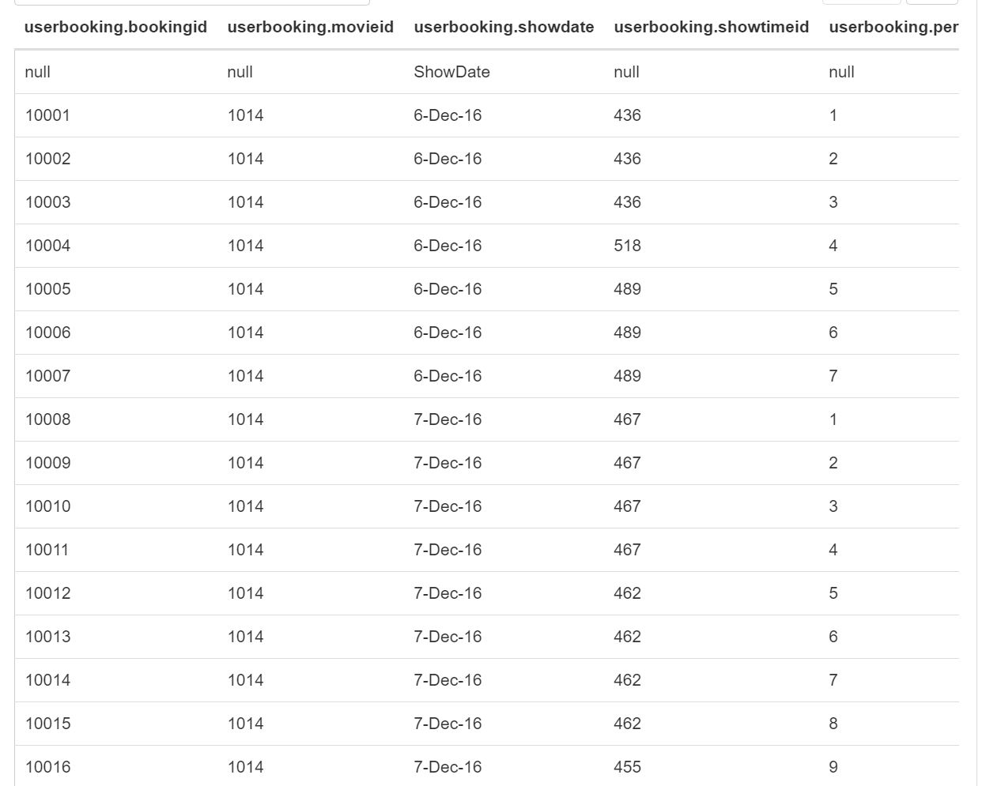

---------------------------------------------------------------------------------------------------------------------

**61. Screen**

CREATE TABLE Screen (

ScreenID Int,

Name String ,

ModifiedString String ,

ModifiedBy String

)

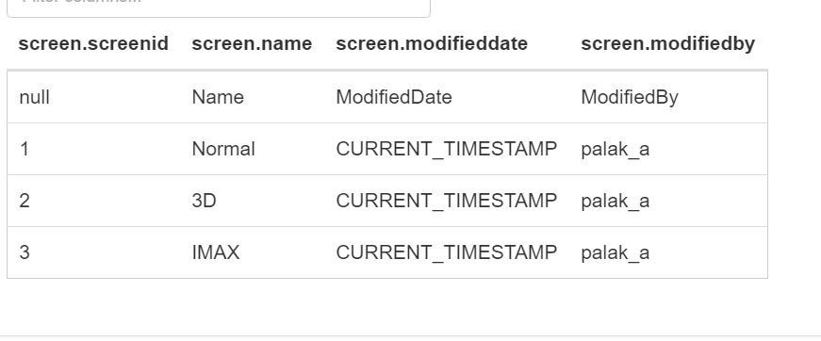

---------------------------------------------------------------------------------------------------------------------

**61. ReleaseLanguage**

CREATE TABLE ReleaseLanguage (

LanguageID Int,

MovieID Int,

TVShowID Int,

ModifiedString String ,

ModifiedBy String

)

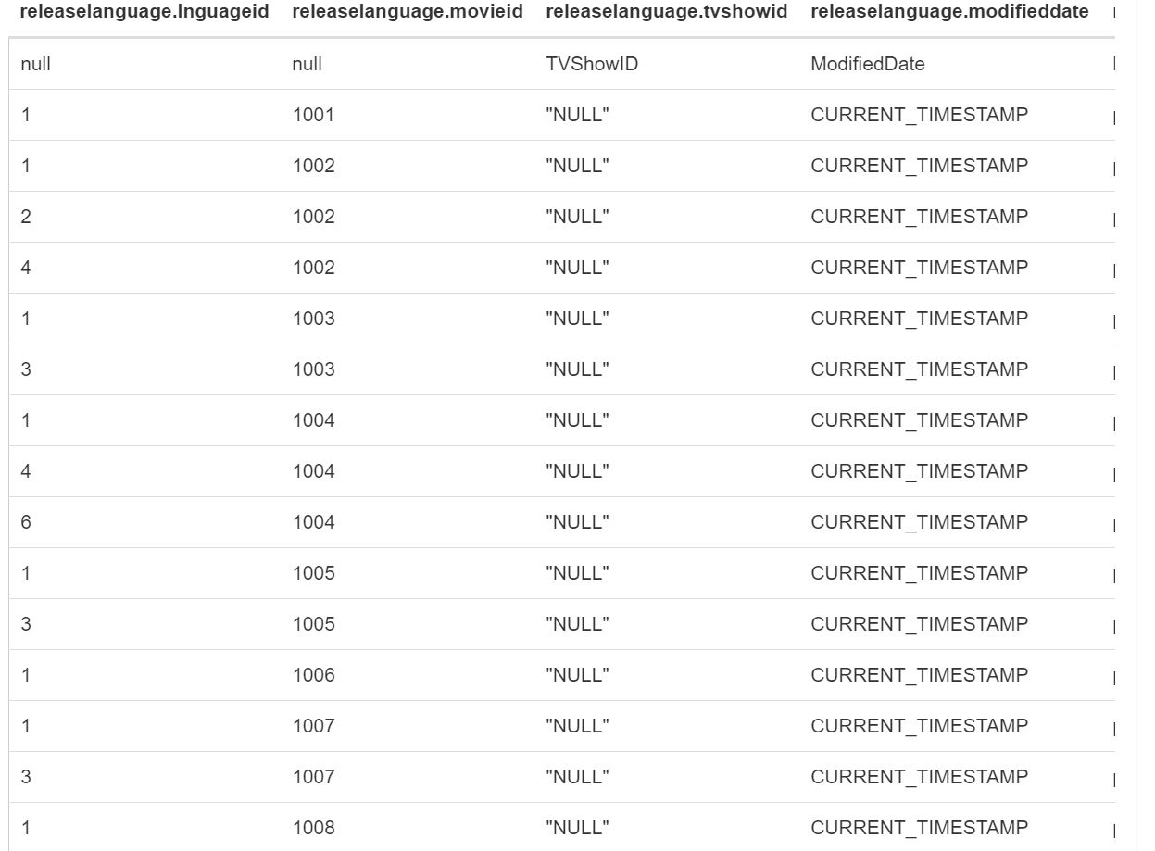

---------------------------------------------------------------------------------------------------------------------

**62. BoxOfficeCollectionDate**

CREATE TABLE BoxOfficeCollectionDate (

BoxOfficeCollectionID Int,

CollectionString String ,

DayOfWeek String15 ) ,

ModifiedString String ,

ModifiedBy String

)

----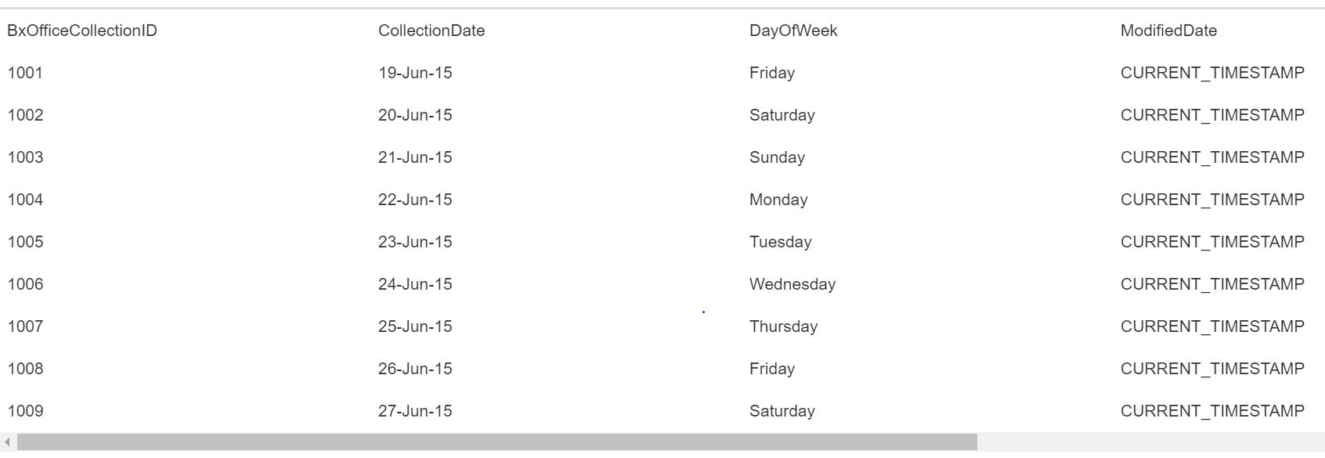-----------------------------------------------------------------------------------------------------------------

**63. BoxOfficeCollectionOfMovie**

CREATE TABLE BoxOfficeCollectionOfMovie (

MovieID Int,

BoxOfficeCollectionID Int,

CollectionAmount Int,

ModifiedString String ,

ModifiedBy String

)

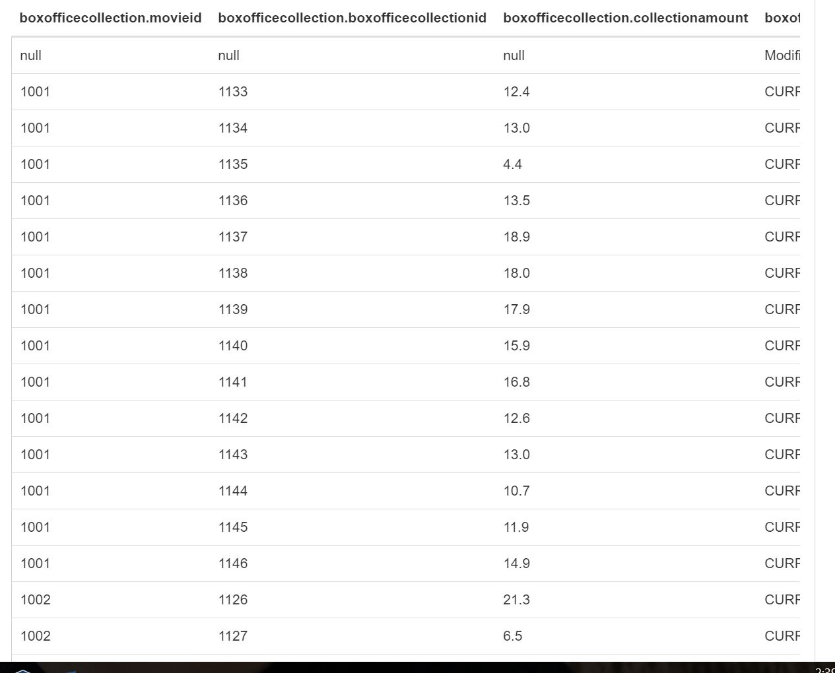

---------------------------------------------------------------------------------------------------------------------

**64. ProductionForMovieOrTV**

CREATE TABLE ProductionForMovieOrTV (

ProductionID Int,

MovieID Int,

TVShowID Int,

ModifiedString String ,

ModifiedBy String

)

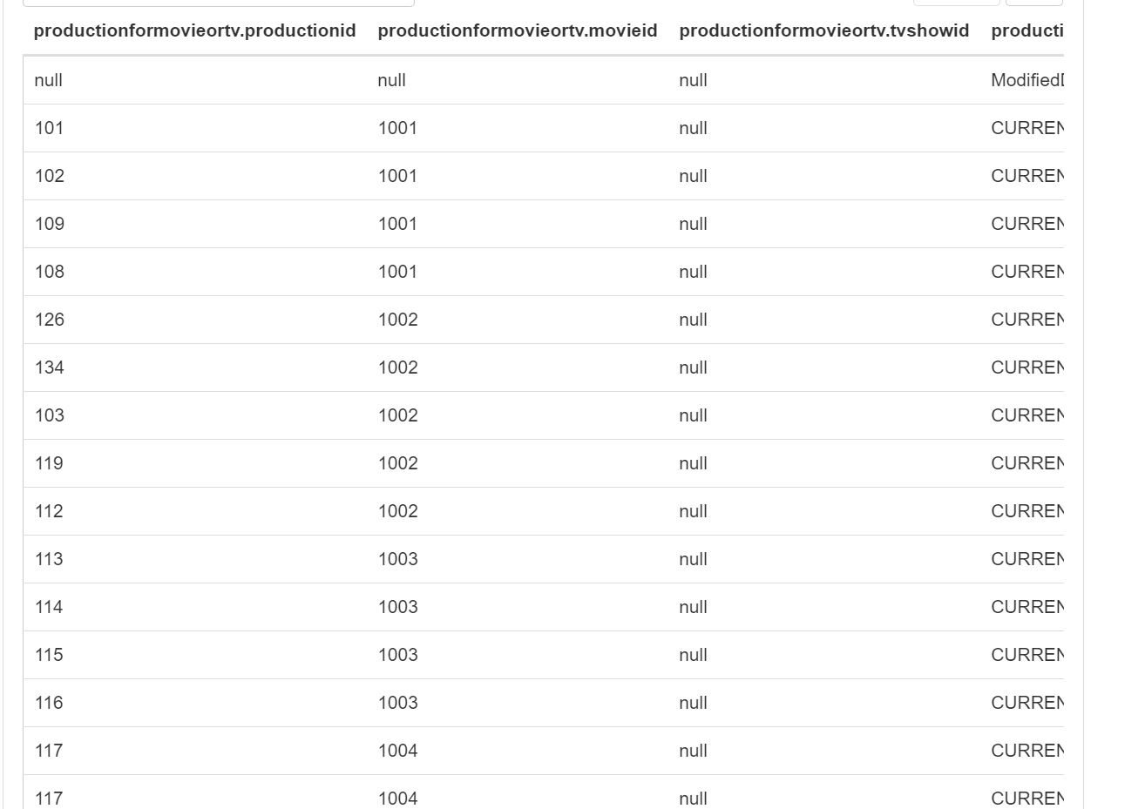

---------------------------------------------------------------------------------------------------------------------

**65. Certificate**

CREATE TABLE Certificate (

CertificateID Int,

CertificateName String5 ),

Description String ,

ModifiedString String ,

ModifiedBy String

)

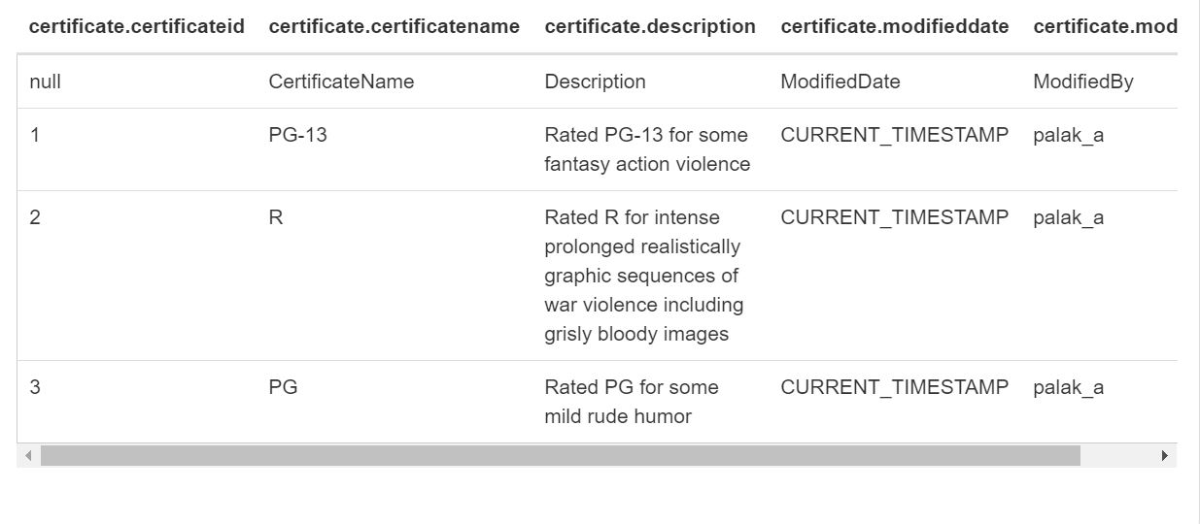

---------------------------------------------------------------------------------------------------------------------

**66 MovieFilmingLocation**

CREATE TABLE MovieFilmingLocation (

MovieID Int,

LocationID Int,

ModifiedString String ,

ModifiedBy String

)

